Master thesis

Do sports facilities increase activity in sports clubs?

Supervisor:

Jon Fiva

Hand-in date:

31.08.2020

Campus:

BI Oslo

Examination code and name:

**GRA 19703 MSc Business Analytics 2018-2020**

Programme:

MSc Business Analytics

Table of content

Abstract ii

Acknowledgement iii

Introduction 1

Review of literature 6

Data 10

Data sources 10

Datasets from The Norwegian Sports Federation (NIF) 10

Age group differences 11

Sports federation differences 14

Facility register from the Ministry of culture 19

The Norwegian Social Science Data Service (NSD) 25

Local Government Dataset 25

Zip codes from Bring and www.erikbolstad.no 25

Models and analysis 26

Variable description and variable creation 28

Model 32

The within estimator – fixed effect model 34

Municipality differences 37

Analysis 40

Model estimations 42

Sports federation coefficients 44

New sport-specific facilities and development of the number of sports members 47

Summarizing the assessments of the federation effects 57

Multifunctional sports facilities 58

Robustness 64

South, North / Small, Medium, Large municipalities 64

Strengths and limitations 66

Conclusion 71

References 75

# Abstract

Sports and sports activity have been an essential factor in my childhood, and as a grownup, I see the importance of sports activity. In this master thesis, I have investigated how the number of sports facilities affects sports clubs' activity in Norway. By using the methodology of causality with the provided data for Norges Idretsforbund, it has been possible to estimate how the number of sports facilities per capita affects the population's active share in the Norwegian municipalities. I have used a fixed-effects model to estimate the coefficients of those sports federations in Norway, who has been possible to match with a sports-specific facility. The results show that most sports federations have a positive effect when the number of sports facilities per capita increases. But there are significant differences between sports federations and municipalities.

# Acknowledgement

I want to thank my supervisor Jon Fiva for his fast and constructive guidance and support. His advice and counseling have been of great value and have made this mater thesis possible. Furthermore, I am grateful that Norges Idrettsforbund provided me with data that made it possible to create an analysis of sports activity and sports facilities in Norway. A special thanks to Terje Kleven in NIF for charging knowledge about the data. I want to thank my ex-husband Jan Egil Sponnich and my childhood friend Vibeke Solvang for their proofreading.

Last but not least, I would like to thank my family who has supported me these two prior years and especially my children for their patience with me through the thesis process; all their support has inspired me to go further when things have been difficult.

# Introduction

Research shows that physical activity has good benefits for people's health. The Norwegian sports clubs play a vital role in offering a physical activity to the nation's population, incorporating the Norwegian National Sports Federation (later mentioned as *NIF*). *NIF* has a goal to offer "activity to everyone" (Norges Idrettsforbund, 2019). WHO launched More Active People for a Healthier World, and the UN and IOC acknowledged that sports have a vital role in creating development and peace in the world. The UN Plenary resolution of 03.12.2018 states the importance of sports and has the title "Sport as an Enabler for Sustainable Development". Sports clubs offer physical activity to the people and, in many cases, a vital role in many people's lives by offering activity and good communities.

One of the most crucial factors to make it possible to offer activity through sports clubs is the possibility to have enough sports facilities for all the different sports in Norway (Norges Idrettsforbund, 2019). Sports policymakers have meant that Norway and Denmark are among the countries with the highest number of sports facilities worldwide (Rafoss & Troelsen, 2010). During decades there has been built a high number of new sports facilities, both in Denmark and Norway, but it is stated that it is still too few sports facilities to make it possible to let the diverged organized sports be a possibility for everyone. An earlier research paper mentions that "Despite the relatively high number of sports installations in Scandinavia, the expansion in facilities has not kept pace with new sports movements and cultures. Many of the existing sports facilities are either outdated, mono-functional, or built mainly for spectator sports." (Rafoss & Troelsen, 2010) The lack of sports facilities for diversity in sports activities is the most significant limitation of physical activity among children and youth in Norway (Norges Idrettsforbund, 2019).

*NIF* is the union of the sports associations gathered with the same common interest in the sports in Norway. Some of *NIF's* goals in the next four years are to create more physical activities through the sports clubs, make room for those who

do not participate in the sports clubs and secure more areas to physical activity (Norges Idrettsforbund, 2019). Every year new sports facilities are funded through the established law, *Pengespill loven*. The law was set up by the Norwegian government in 1992, and stated that the profit from gambling through *Norsk Tipping AS* should give funding to sports facilities and physical activity in Norway. The purpose of this funding is to allow the Norwegian population to get the opportunity to do physical activities through organized sports and self-organized activities (The Ministry of Culture, 2019).

Since the Second World War, enormous amounts have been invested in sports facilities in various sizes. From 1949-2011 it has been subsidized sports facilities for an amount of 21 656 million NOK, which is 4 400 NOK per inhabitant, if the amount is converted by number of inhabitants in Norway in 2011. In the same period there has been invested in sports facilities across the municipalities for an amount of 55 to 65 billon NOK, which is an invested amount between 11 000 NOK and 13 000 NOK per inhabitant, if the amount is converted by number of inhabitants in Norway per 2011. Fourteen thousand one hundred sixty-two million of the funded amounts, in this period, are funded from 1990 to 2011, to build new sports facilities (Breivik & Rafoss, 2017). In 2018 the government funded the sports activities in Norway with 3 185 million NOK, which is 600 NOK per inhabitant in Norway. The central part of this amount was the funding of sports clubs. Funding of sports facilities in 2018 amounts to 23 378 million, which is 4 400 NOK per inhabitant in Norway, and the central part of this amount is the funding of sports halls and activity rooms. Two-thirds of the funding are related to gymnasiums, football fields, and indoor swimming pools. These large investments can be seen as investing in the population’s health and wellbeing. In average the cost of building a sports facility is calculated to be approximately 1.400 NOK through 2018 per citizen (NIF's Anleggsrapporten, 2018) (Flekkøy, 2020).

Earlier research shows that children are less active during a day than earlier. A Norwegian 15-year-old youth has sedentary activity of two third of the day and nine-year-old children have a decline in activity through the day. The research

from Norway shows that children in general are less active (Mårdalen, 2019). Regarding the registered activity in sport clubs from *NIF* the last 18 years shows a continues increase in sport club activity, but it seems to flatten out from 2010 or 2011, as shown in the graph appendix figure 1. During 18 years, the Norwegian population has also increased. To give a clearer picture the actual active share of the population in sports clubs is presented in appendix figure 2. The graph shows a 5 percentage point increase in the actual active share of the population from 20 % in 2001 to 2018, where the active share of the population participating in sports activity in sports clubs are 25 %.

From childhood through youth to being a grown up the interest in activity and hobbies shifts rapidly, and children and youth shifts more rapidly than grownups. Several of the sports federations report both increase and decline in their active memberships from their member sports clubs. The Norwegian ski federations report a decline in cross-county skiing, and a survey explains the decline in competition from other sports, the social environment and the economy. The Norwegian Gymnastics Federation experience the opposite, and has had the largest increase from 2012 to 2018 (Dagsavisen, 2019). To underline this, *NIF* and the Norwegian Gymnastics Federation mention one of the sports clubs from the gymnastic federation had a significant increase in active gymnasts after they built a new gymnastic hall (NGTF, 2019).

Based on the importance of activity and all funding of sports facilities by the Norwegian government, this master thesis will look into the causal effect on how the active share of the population is affected by new sports facilities built in

municipalities – " Do sports facilities increase activity in sports clubs?"

The thesis is based on data from Norwegian Social Science Data Service (NSD), The National Norwegian Sports Federation, the sports facility register from the Ministry of Culture (The Ministry of Culture, 2019), Bring and Local Government Dataset (Fiva, Hasle, & Natvik, 2020). These five datasets are combined into one dataset with information on 52 different sports federations across 369 different

municipalities over a period from 2001 to 2018. The activity divides into *NIF* predefined age groups[1]. The Norwegian population and sports facilities across all municipalities includes in the data. All sports clubs are matched with their municipality, and all sports facilities who have been possible to match with sports federations like a shooting facility are linked to the Norwegian Shooting Federation. The data make it possible to create estimations of what effect sports facilities has on the active share of the entire population of Norway. The data have a large variety of information about active sports members in sports clubs and the number of sports facilities counted after construction year. The chapter "Data" will describe in more detail how the different datasets are merged and its variety of information.

*NIF* contains of 52 different sports federations that represent more than 100 different sports. But the diversity of different sports with different demand of facilities needs is large. Some sports can offer their activity in ordinary sports halls and some needs of more specialized facilities. The activity numbers from *NIF* show that there are significant differences in activity and number of active sports members across the different sports federations. The largest sports federation in 2018 is the Norwegian Football Federation, with nearly 300.000 sports members represented across all municipalities in Norway, to the smallest federation – Norwegian Softball and Baseball Federation with 364 members in 2018.

As shown in appendix 1, the total number of active sports members in 2018 was more than 1,3 million, and at the same time 18.831 sports facilities meant for organized sports across all municipalities. The sports facilities registered in the facility register from the Ministry of Culture are all sorts of facilities. From small school gymnasiums and multifunctional sports hall to sports facilities specialised for different sports and large national sports arenas as football courts and ski arenas. As described in the “Data” section, the facility register are divided into

different categories, like indoor and outdoor facilities, facilities for organized sports and facilities for the public. There are a large variety in numbers of sports facilities between the municipalities in Norway.

The number of sports facilities has increased in the last decades. (Breivik & Rafoss, 2017). The graph in appendix figure 3 shows how the average number of sports specific facilities per capita has developed through the last 18 years. In 2001 there were 0,025 sports specific facilities per capita for the Norwegian population. The number of sports specific facilities per capita has slightly increased to the top in 2016 where there were 0,0027 sports specific facilities per inhabitant in Norway. There are some uncertainties about the facility register's construction years from the Ministry of Culture, which may explain the dip in 2017 shown the graph in appendix figure 3 (Breivik & Rafoss, 2017).

Since the facilities are one of the limitations of offering sports activities, the causal effect methodology is used to look into the effects on how the number of sports facilities per capita affects the active share of the population in organized sport. By using a longitudinal dataset created from the different data sources with a fixed-effects model, the number of sports facilities per capita are used to estimate the effects on organized sports activity share per capita for the Norwegian population across all the municipalities in Norway. The estimations from the estimator creates the effects for each sports federation with a sports specific facility linked. Four different federations are analysed by randomly picking municipalities that have built new sports-specific facilities to substantiate the results from the fixed-effects model. In addition, I have looked into different municipalities and how their active share in sports clubs has changed after how multifunctional sports facilities are constructed in their municipality. A robustness check is created to see how sensitive the model is regarding the number of observations. These estimations are created based on how SSB divides the Norwegian municipalities after, among other things, economy, and inhabitants.

The analysis shows that the data are highly variated, both within a municipality and across the municipalities. The separate coefficients from the fixed-effects model for each sports federation indicates that there is a positive effect on the active share of the population, when the number of sports facilities increases per capita. However, there are significant differences in the effects between the different sports federation. Sports facilities is a crucial factor offering sports to the citizens, but there must be taken into consideration that reversed causality violate the estimations from the fixed-effects model, which makes it harder to estimate statistically significant results.

The results from the analyses show that an increased number of sports facilities per capita increases the active share of the population. But there is variation in how the effects are. The Norwegian municipalities are diverse by size, economy, and the number of inhabitants etc. The analysis writes down that there are differences if a new sports facility is built in a large or a small municipality. The same count for the different sports federation. Some of the federation has statistical significantly affects from a new facility another has smaller or nor effect at all. The overall conclusion is that sports facilities creates more activity but there are as well indications that an increased diversity in sports creates the need of more sports facilities.

# Review of literature

The interest in sports and the relationship between sports facilities and sports capture the interest of many around the world. You find a lot of literature about the relationship between sports facilities and sports. Most of these reports published in the United-Stats some are from Oceania, Europe, and very few from the Nordic countries. (Limstrand T. , 2008). There are many factors that are studied such as; age (Limstrand T. , 2008) (Reithaug, 2017) (Breivik & Rafoss, 2017), infrastructure, and availability (Reimers, et al., 2014) (Wicker, Hallmann, & Breuer, 2011). For the age factor, the trend in many countries is that sports activity decline from the age of 15 because the activity moves from traditional sports facilities to private gyms. These changes indicate that sports facilities have not been appropriately adapted to the changes in activity profiles among adults (Limstrand T. , 2008) (Limstrand & Rehrer, 2008) (Breivik & Rafoss, 2017) An exception is Denmark and China, where, especially in Denmark, you see activity in sports facilities for the age group over 15 (Huan, 2007) (Rafos & Troelsen, 2010). An explanation for this is that these two countries have built sports facilities in the countryside and in comparison, to Norway, Denmark has three times the number of sports facilities. This is in line with the literature that investigates infrastructure and availability and shows that the distance between home and the sports facilities impacts whether the activity happens inside or outside the sports facilities. (Rafos & Troelsen, 2010). In Denmark activity remains stable up to the age of 60, and not until 60-75 years a decline in activity can be shown (Rafos & Troelsen, 2010). The most dominate age group in Denmark are from 40-59 years due to the fact that activities such as badminton and especially gymnastics appeal to these age groups.

In Norway as in other countries there are differences in the possibility to take part in sports. Earlier studies in Norway show that factor like where you liv, the size of the city, small or large, city or countryside. In some parts of Norway has more activity like Oslo and middle of Norway (Møre og Romsdag/Trøndelag) (Breivik & Rafoss, 2017) (Limstrand T. , 2008). Other important factors which affects the possibility to take part in sports is the differences in both low social economic status (Limstrand T. , 2008). In a study from 2017 in Oslo it seems to be a connection between social economy and participation in sports activities. The higher social economic status the family have, the children participates more in organized sports activities (Reithaug, 2017), other important factors are gross income and total household income. Households in the lowest income class seems to twice as less active compared to the highest income class (Breivik & Rafoss, 2017).

Another key factor for sports participants stated is the infrastructure and how available sports facilities are for the whole population (Reimers, et al., 2014). Many counties, like China, Australia and UK, seeks the goal to increase the sports participation in the nation and they sees that the infrastructure have an important role to reach an increase in activity (Wicker, Hallmann, & Breuer, 2011).

The financial fitness program in China supported new sports facilities particularly in urban areas. By built more facilities in the urban aeras and not just in the larger cities, mass sport participation has grown substantially (Wicker, Hallmann, & Breuer, 2011).

Many sport activities require specialized sport facilities like swimming, shooting, gymnastics to perform the sport. Several articles have an intention to look into the relationship between sports activity and sports facilities. There has been investigated how sports field, park area and gymnastic/ dancing rooms influences on whether an individual practise sport in a sport club or not. (Wicker, Hallmann, & Breuer, 2011). Others investigates the distance from home to the sports facilities has an impact on sports activity inside and outside of sports clubs. The results from the report point out that in larger cities, the distance from home to a sports facility does not have a huge impact, but in smaller cities and rural areas, the distance makes a difference. There has been looked into how sports field, park area and gymnastic/ dancing rooms influences on whether an individual practise sport in a sport club or not. (Wicker, Hallmann, & Breuer, 2011). Others investigates the distance from home to the sports facilities has an impact on sports activity inside and outside of sports clubs. The results from the report point out that in larger cities, the distance from home to a sports facility does not have a huge impact, but in smaller cities and rural areas, the distance makes a difference.

The diversity in sports interests in the nation requires both multifunctional facilities and sports specific facilities. Swimming halls are meant to influence water sports activities like swimming and water polo for sports clubs (Reimers, et al., 2014). The report from Reimers, et al in 2014 can't prove any significant relationship between a tennis court and a swimming hall in the neighbourhood and people's activity in sports clubs (Reimers, et al., 2014). None of the earlier studies of the relationship between available sports facilities and sports activity prove that there is a relationship between activity and sports facilities. Common for earlier

research show that there are many various factors that affects an individual choose to participate in sports activities. Both measurable factors like facilities, age, economy, gender, and ethnicity, but also unmeasurable factors like cultures and personal interests affect participation in sports activity in all age groups.

Danish spots activity has a different pattern than other countries associated with the active age groups. The Danish population are active in sports facilities until an age of 60 to 75 years old compared to other countries where the activity decline from an age of 15. In Denmark the sports facilities are in larger scales on the countryside which explains these differences. The same pattern can be fund tin China where there has been a significant increase in mass sports in the age group from 16 years and older after building sports facilities on the countryside. China’s sports reform which has a goal that people should have the possibility to choose sports which satisfies their own needs and purposes. The reform has let the diversity in people’s needs for different sports to be possible (Huan, 2007).

Other not measurable factors which may affects people’s activity in sports clubs are introduction to new technology that captures especially children and youth. A Ph.D. report stat that there seems to be a connection between fat children and frequent use of screen-based media (Graven, 2012).

This master theses have the purpose to investigate what the effects of an increase in the number of sports facilities in Norway has on the activity in the sports clubs. As earlier research states that there are a lot of factors that may affect sports activity in a country. In this master thesis I will use the methodology of causality to see if more sports facilities affect sports activity in sports clubs. All else equal, does sports facilities increase sports activity in sports clubs? By looking into that sports facilities are counterfactually dependent on sports activity. Would the number of active sports members have been different if the number of sports facilities been different (Morgan, 2013).

# Data

## Data sources

The master thesis is based on data collected from five different data sources:

* Sports member data from The Norwegian Sports Federation (NIF)
* Sports Facilities from the Facility register from the Norwegian Ministry of Culture
* The population in the different municipalities from The Norwegian Social Science Data Service (NSD)
* Population and municipality numbers from the Local Government Dataset. (Fiva, Halse, & Natvik, 2020)
* Zip codes and municipality numbers from Bring and more zip code information from the web site erikbolstad.no (Bolstad, 2020) (Bring, 2020)

By combining the five different data sources a panel data was created. The complete description of how the panel data was built are explained in appendix 4.

## Datasets from The Norwegian Sports Federation (NIF)

Yearly all sports clubs report to *NIF* their active sports members through their respective sports federations. *NIF* uses these numbers in their yearly report about sports activity in Norway. The provided data contains data from all sports clubs, and sports federations across all age groups for the period 2001 to 2018.

One weakness in the data is that the number of active sports members is not counting unique persons. One person may be registered both in football, handball, and skiing in the same year. *NIF* has estimates on how many unique persons who are registered in total in three different age groups. In the age group from 6 -12 years, 70% of the total number of active members are unique. In the age group 13 – 19, years 72% of the registered members are unique persons. In the third group, 20 – 25 years, there are 76% unique persons registered (NIF, Norges idrettsforbund, 2020). Because of the weakness, the original activity data reduced to the estimated unique person level.

### 

### Age group differences

All active sports members are divided into different age groups. In Figure 1 the total number of sport members registered in a sports club in 2018 are divided into the age group 0-25 and above 26 years. The graph shows that in 2018 the majority of active sports members are people within the age group of 25 years and younger.

Figure 1 All active sports members in 2018 divided into the age groups 0-25 years and from 26 years and older. The y-axis represents the number of active sports members in 2018

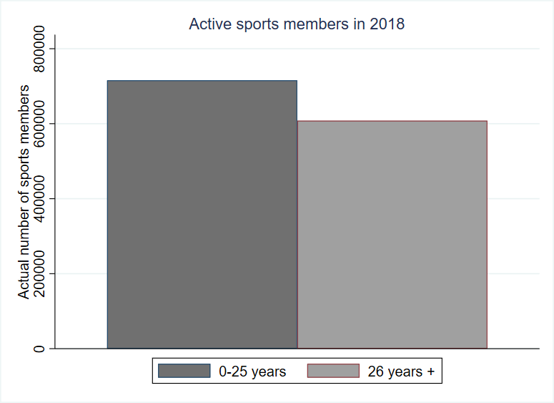

The trends for active sports members in sports clubs have increased continually the last 18 years as shown in Figure 2. The trends show that for the youngest children between 0-5 years and older youth, 20-25 years, have small changes. For the age group from 6 to 12 years the trends show that the activity has increased at the same rate for people from 26 years and older. From 2001 to 2018 the registered sports members have increased by 47 %, and at the same time the Norwegian population has increased with 17.5 %. Seen in the light of the inhabitants in Norway in 2001, the active share of the population was 19,8%, and in 2018 the share was 25 %, this shows an increase of 5,2 percentage points.

Figure 2 The figure shows how the different age groups active sports members in organized sport has developed the last 18 years. The x-axis represents the years from 2001 to 2018, and the y-axis represents the number of active sports members by age group.

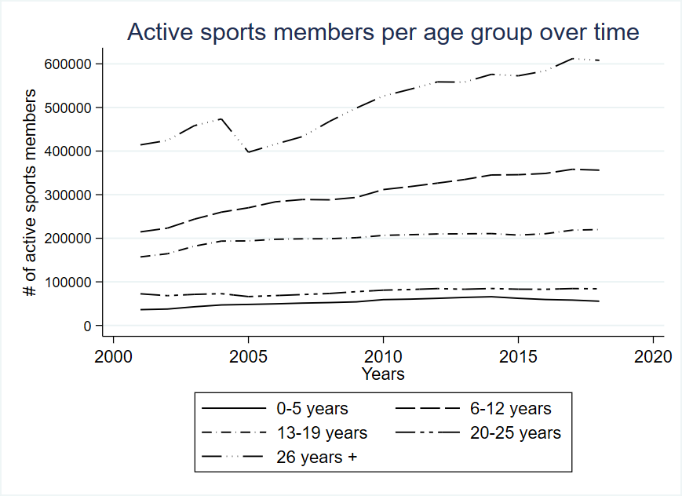

The collected data has information on the entire population in Norway, and all the active sports members registered in a sports club in Norway. The illustration in Figure 2 illustrates how the different age groups are represented in sports in 2018. The age group 6-12 years and 13-19 years represent the members of the most active sports group overall, represented by 898 000 members or 69% of all active sports members. This group has nearly 300 000 more active sports members than for the age group above 26 years.

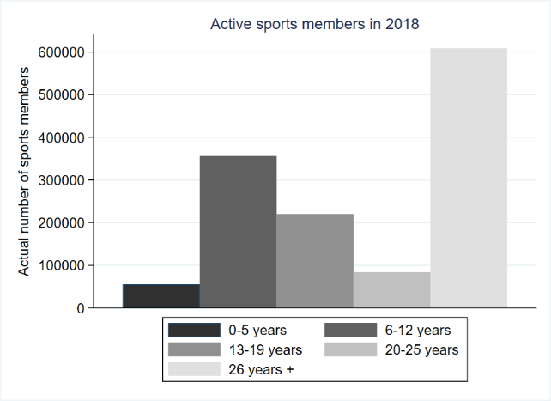

Figure 3 The bar chart illustrates how the actual number of sports members distributed across the different age groups in 2018. The x-axis stands for the different age groups and the y-axis stands for the actual number of active sports members.

By nature, the group of people from the age of 26 and older, has a significantly smaller active share of the population. A part of the explanation of the differences is that the whole population in the age group over 26 years is significantly larger than the age group from 0 until 25 years old, and in the age group from 26+ years, people choose to participate in other activities than in sports clubs (Breivik & Rafoss, 2017).

Figure 4 The bar chart represents the distribution of the active share of the population. The graph illustrates that main active share of the population are in the age groups from 6-19. The y-axis represents the percentage active share of the population in 2018

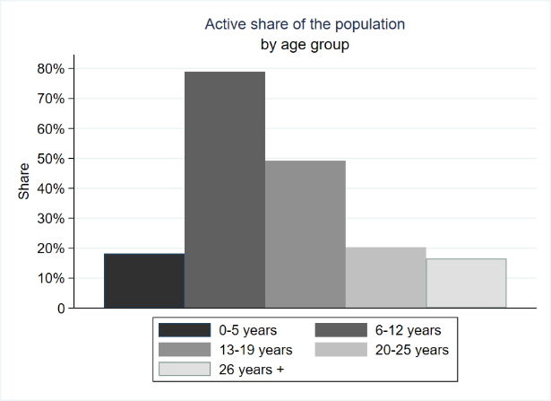

Figure 4 shows that 80% of all children between 6 and 12 years old participates in some kind of sports activity through sport clubs. From an age of 13 the activity in sports clubs states to decline. The graph clearly shows us that the most active sports members in sport clubs are those between 6 and 19 years. This confirms the statements from Breivik and Rafoss that older youth use private gyms instead of activity through the sports clubs (Breivik & Rafoss, 2017).

### Sports federation differences

The provided data from *NIF* was collected in January 2020, and was divided after the new municipality constellations, which was established on 01.01.2020. The reform merged many of the municipalities into larger units, and since the master thesis analyzes data for the period 2001 to 2018, *NIF's* division of the municipalities cannot be used. Based on these changes in municipalities, I had to use a more specific dataset from *NIF,* with activity data for each sports club in

Norway, and place them into the correct municipality based on the sports club zip codes. Zip codes and municipality numbers are collected from Bring (Bring, 2020) and the web site erikbolstad.no with geographic data (Bolstad, 2020).

In total, there are 52 different sports federations in Norway, and the five largest federations per 2018 are football, skiing, handball, golf and gymnastics as shown in Figure 5, where the development for these federations are illustrated.

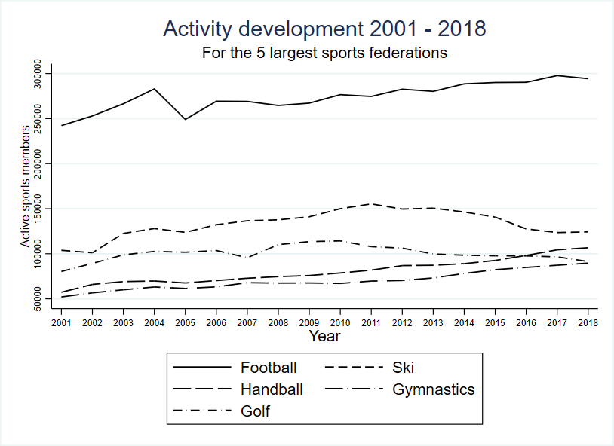

Figure 5 The graph shows how the sports activity for the 5 largest sports federation has developed the last 18 years. Football, handball, and gymnastics has had a continues increase in the number of active sports members, unlike Skiing and Golf that has had decreased. The x-axis stands for the years and the y-axis represents the number of active sports members in each sports federation.

The Norwegian Football Federation is in a class of its own with 300.000 members and has had an increase of nearly 100.000 the last 18 years. A clear pattern in the graph shows that skiing and golf have decreased since 2011, and the three other federations (Football, Handball and Gymnastics) have had a continuous increase in active members. Seen in the context of how the whole population in Norway

has increased the last 18 years, and by looking at the active share of the population, creates a different picture.

The actual development of the actual active sports members has had an increase in the last 18 years, as shown in appendix figure 1. There is, as well, a significant variation in size and development of the activity in each sports federation.

Table 1 gives an overview of the total number of sports federations grouped after the size of the federation in 2018.

**Number of active sports members after sports federations size**

|  |  |  |  |
| --- | --- | --- | --- |
|  | | | |
|  | **Number of federations** | **Total** | **Total share** |
| **Sports federation groups** |
| >150' | 1 | 294 325 | 22.2% |
| 100'-149' | 3 | 320 542 | 24.2% |
| 50'-99' | 3 | 218 563 | 16.5% |
| 10'-49' | 18 | 384 744 | 29.1% |
| <10' | 27 | 105 840 | 8.0% |
|  | | | | |

Table 1 The table summarize the total number of active sports members divided after the size and the sports federation in **2018**. The first column shows the number of federations in each group. The second column are the actual active sports members. The third column represents the standard deviation for each group and the last column shows the share of the total active sports members represents in each federation group.

The three first groups of sports federations stand for nearly 63% of all actual active sports members in Norway, distributed over seven sports federations outwards. The Norwegian Football Federation reigns supreme in the first group alone with more than 150 000 sports members. In the category where the sports federations have less than 10 000 sports members, it holds the largest group of sports federations but represents the smallest number of active sports members.

The ten largest sports federations represent more than 1,1 million of the total number of active members in sports clubs. In both skiing and golf there is a decrease in the actual numbers of active sports members, from more or less 2010. At the same time, around 2010, handball, gymnastics, and athletic have a continuous increase in actual number of sports members. These time trends create a picture of how sport shifts. At the same time, it has been an increase in the whole populations in Norway. To get a clearer picture of how the activity in Norwegian sports clubs has developed is done by investigating the active share of the population. In Figure 6 the ten largest sports federations are shown separately. The rest of the federations are collected in one graph (Other), and shows the active share of the whole Norwegian population across all municipalities and sports federations.

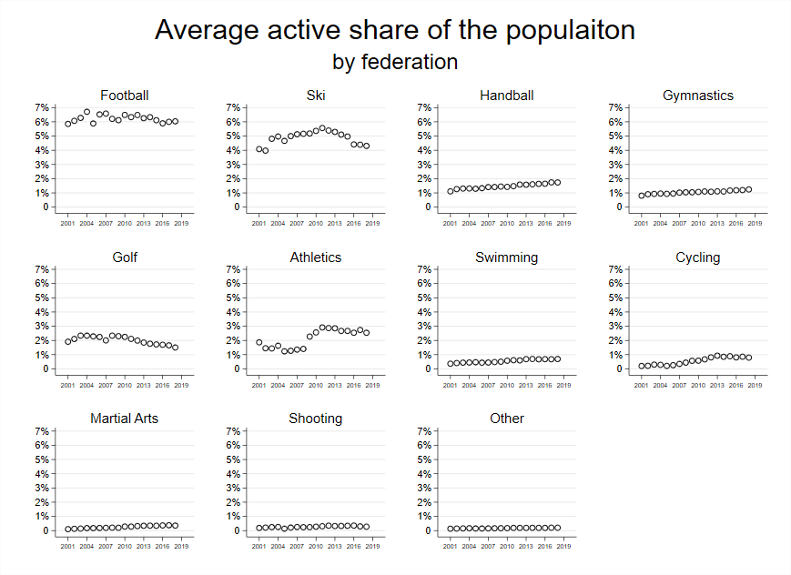

Figure 6 The 10 largest sports federations represents more than 1,1 million of the active sports members in Norway. The y-axis stands for the average active share of the population across all the municipalities, and the graph shows each federation development the last 18 years. The x-axis represents the years and the y-axis represents the average active share of the population across all municipalities and sports federations.

These scatter plots in Figure 6 shows, the average active share of the Norwegian population across all the Norwegian municipalities, by the ten largest sports federations. These graphs show the same picture as the actual number of active sports members. Football has some small changes during the years and thrones at the top of the active share of the population. Skiing and Golf have had a decrease from around 2010, and the rest of the largest sports federations have had a slightly increase in their active share of the population.

The data contains information of the whole population, and in Figure 7 the average active share, of sports members in sports clubs are presented, across all Norwegian municipalities. In 2012 the average active share of the population across all municipalities and sports federations reaches a top of 0,74%. From that year and until 2018 there has been a slightly decrease in the average active share of the Norwegian population represented in sports clubs in Norway, which confirms the information from Breivik and Ranfoss where the survey data show that the Norwegian population are less active in sports clubs (Breivik & Rafoss, 2017).

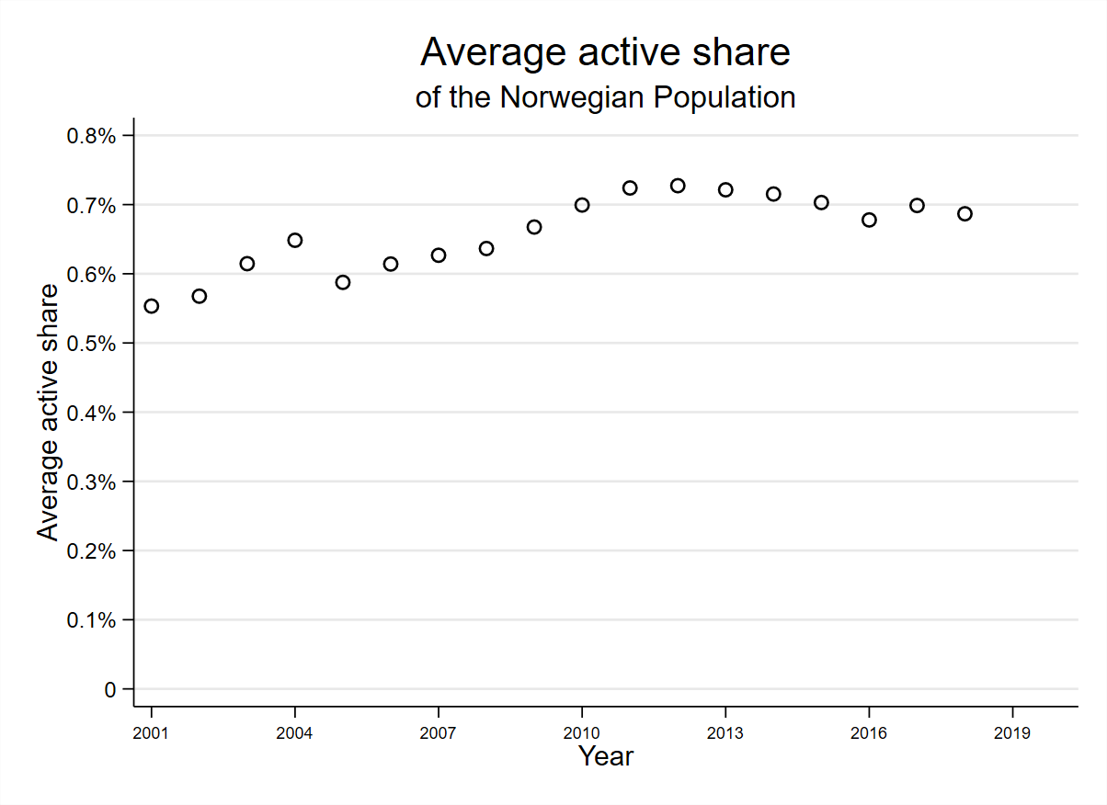

Figure 7 The graph show the average active share of the population across all sports federations and all municipalities in Norway, and represents the developed the last 18 years. The x-axis represents the years and the y-axis represents the active share of the population.

## Facility register from the Ministry of culture

The Norwegian Ministry of Culture provides a total overview of all cultures and sports facilities in Norway with information about the owner, construction year [2] and municipality. The facilities are divided into facility classes, facility categories and facility types.

The facility class divides into four different classes; local facilities, ordinary facilities, inter-municipal facilities, and national facilities. The local facilities are defined as outdoor facilities for children from the age of 6-19, and not customized for organized sports and competitions (The Ministry of Culture, 2019) . The ordinary facilities are related mainly to competition and organized sports activity. However, this facility class contains several categories of facilities that are not intended for use in competitions and organized sports activities, like outdoor facilities and skating facilities (The Ministry of Culture, 2019).

Further assessments [3] have been made regarding the facility dataset, and specific categories are removed from the dataset. Some of the categories that are removed are e.g. wardrobe facilities, clubhouses and other similar facilities without the ability to perform sports activity. A complete list of all the facility categories removed from the facility datasets are shown in appendix table 5.

In 2018 there were 63 different inter municipality facilities, 13 different national sports facilities and 18.755 ordinary sports facilities registered in Norway. In the

last eighteen years, the number of ordinary sports facilities has increased with nearly 4.000, as shown in Figure 8 .

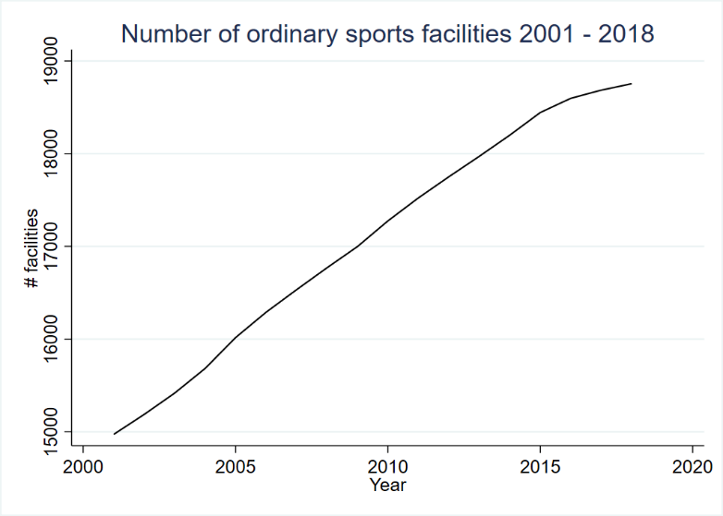

Figure 8 The figure show how the development of ordinary sports facilities has been the last 18 years, with the number of sports facilities on the y-axis, and years on the x-axis.

All the 18.755 ordinary facilities are divided into 20 different types [4] of sports facilities. The four largest facility categories cover three (football, skiing and handball) out of the five largest sports federations activity, see Figure 9.

Figure 9 In 2018 there were 18,755 registered sports facilities for organized sports. The figure shows the total number for largest categories in 2018. In the y-axis the different categories are shown, and in the x-axis the number of facilities is shown.

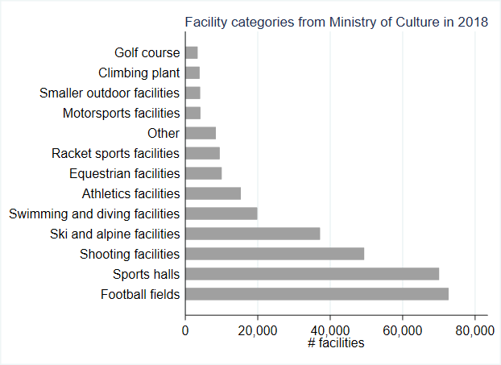

When looking at the total number of sports facilities per active sports member, each football field covers 65 football players, each skiing facility covers 53 athletes, and sports halls cover 46 athletes from handball in 2018.

Further, these facility categories are divided into different types of facilities, e.g. football fields are divided into four different types of fields. Sports halls/ multifunctional facilities are a category that contains of seven different types of facilities like billiards hall, bowling halls, dancing and cheerleading halls, common sports activity halls, and gymnastic halls. With this specific deviation of all the sports facilities it has been possible to match some of the sports federations directly to a specific sports hall type. With these links it has been possible to create estimates on some of the sports federations and how they are affected by the number of sports facilities built over the years. A total overview of how the sports facilities are matched with their sports federations are showed in appendix table 6.

The number of multifunctional facilities has had an increase since 2014 ,except from 2016 when it flattens out and again starts to increase from 2017 (SSB, 2018).

In Figure 10, the average number of sports-specific facilities per capita across all municipalities and sports federations is presented. The sports-specific facilities development has minor changes in the last 18 years, from a level of less than 0.013% per capita to the top in 2018, with 0.017% facilities on average across all municipalities and sports federations in Norway. From 2014 there has been an increase in new sports facilities in actual numbers (SSB, 2018) as confirmed by Figure 10.

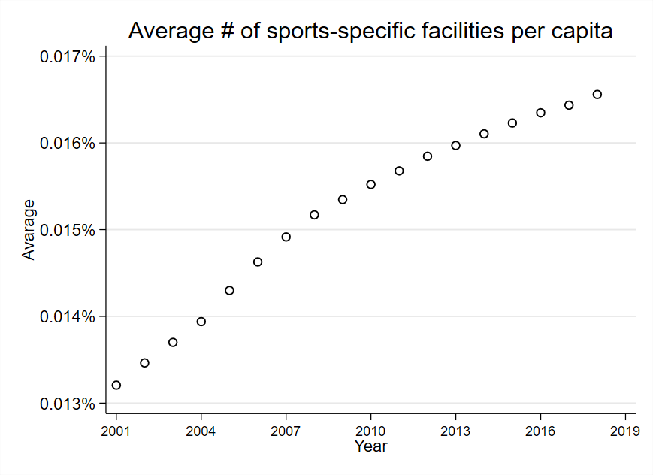

Figure 10 illustrates the average number of sports-specific facilities across municipalities and federations the last 18 years. The average number of sports-specific facilities per capita represented on the y-axis and the years on the x-axis.

By splitting Norway into a northern part and a southern part and look at the average number of sports specific-facilities, per capita, Figure 11 shows that the Northern part of Norway has a slightly higher number of sports-specific facilities per capita than the southern part of Norway.

Figure 11 show the number of sports-specific facilities per capita in north and south of Norway by the average number across the municipalities and sports federations shown in the y-axis. In the x-axis the years are represented.

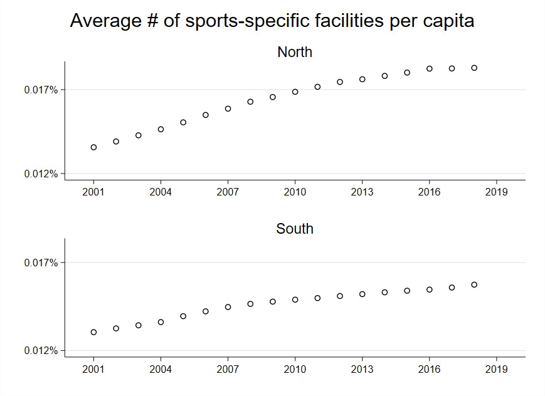

The illustration in Figure 10 show the number of sports specific facilities per capita in Norway. Figure 4 shows the active share of the whole population, represented in each age groups. The age group 6-19 represents the group with the highest active share within their age group. Creating a scatter plot with the active share of the population and the number of sports-specific facilities and averaging the data points across the municipalities and sports federations within 60 different bins, the correlations between the two variables are shown Figure 12. On the y-axis the average active share of the population across all municipalities represented by the sports federations which has a sports specific facility linked. On the x-axis the number of sports-specific facilities per capita standardized as the number of standard deviations from the mean, and all the datapoints averaged within 60 different bins.

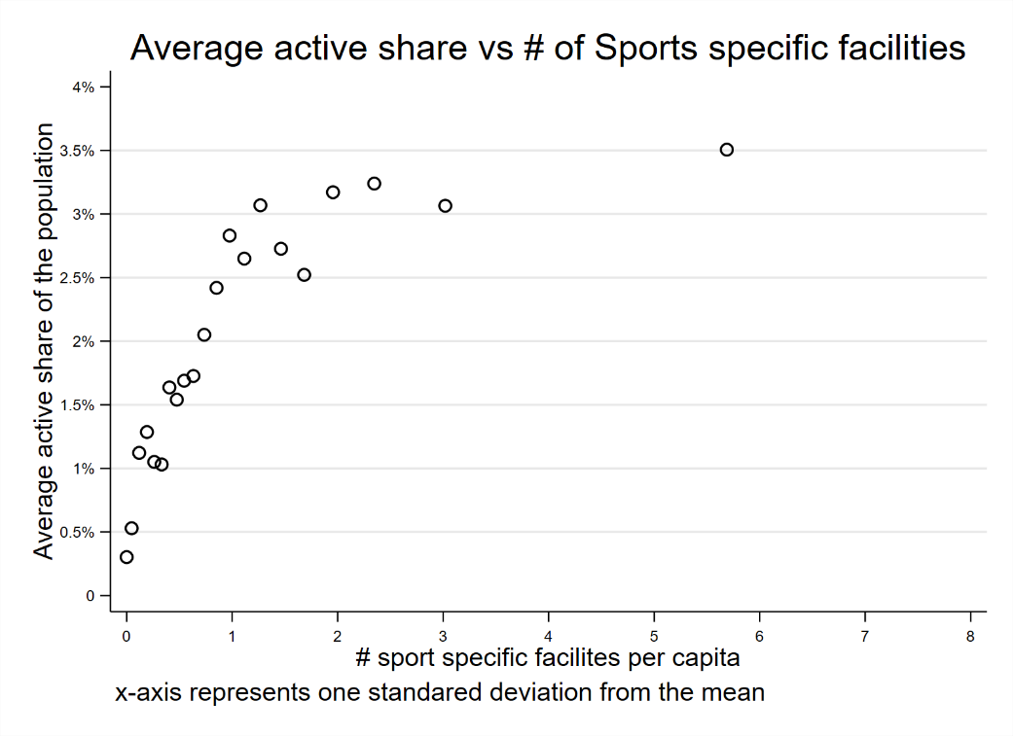

Figure 12 The scatter plot shows the relationship between the number of sports-specific facilities per capita and the active share of the population which are active in sports federation where sports-specific facilities are linked. The x-axis signifies the number of sports-specific facilities per capita showed by the number of standard deviations from the mean. The y-axis signifies the average active share of the population across all municipalities, from the sports federations which have as sports-specific facility linked. The dots in the graph show the average value within each bin.

The graph in Figure 12 shows a clear pattern: when the average number of sports facilities increases away from the mean the average active share of the population increases. When the average number of sports-specific facilities increases by 0.5 standard deviation from the mean the active share on average is approximately 1.75%. At 1.5 standard deviation the active share on average increases to the double compared to the active share at a standard deviation of 0.5. But when increasing the number of standard deviations above two, the average active share of the population flattens out and new sports facilities do not create as much activity. The plot gives indications that by increasing the number of sports specific facilities per capita the average active share of the population increases.

## The Norwegian Social Science Data Service (NSD)

The population data collected from The Norwegian Social Science Data Service are collected separately for each year from 2001 to 2018 with the respective municipality codes. All the data are in collected for each age, making it possible to create the same age groups for the population as the age groups in *NIF’s* data.

## Local Government Dataset

The dataset "Local Government Dataset" provides data about the Norwegian Local governments from 1972 to 2019. The dataset has a substantial number of variables, and the main part of the variables is collected from the Norwegian Social Science Data Service (NSD) and Statistics Norway (SSB). The variables that will be used in the research are the municipality numbers, municipality names, and the total population for each municipality (Fiva, Halse, & Natvik, 2020). The data is as well used as control after merging activity data and population data from NSD.

## Zip codes from Bring and www.erikbolstad.no

Bring controls all zip codes in Norway. Their latest updated zip code register contains information on current and some of the old zip codes in Norway. In addition, all the zip codes are ordered after municipality codes. *NIF*’s address list for sports clubs in Norway contains both new and old zip codes. Since Bring hasn’t a complete list of all new and old zip codes and their associated municipality numbers (Bolstad, 2020), the web site erikbolstad.no is used to find the right zip codes for all the sports clubs in Norway.

# ****Models and analysis****

The compete panel data contains 285.788 observations of 489 different unique municipalities numbers and 52 different sports federations across the municipalities, from 2001 until 2018. During the last 18 years there have been many changes regarding the number of municipalities in Norway. In 2017 and 2018 many small municipalities are merged and approximately 47 new municipality numbers are created. The dataset "Local Government Dataset" makes it possible to keep all municipality numbers, which has existed continually in the period from 2001 until 2018 (Fiva, Halse, & Natvik, 2020).

In chapter “Sports federation differences*”* explain the significant differences between the sports federations. In the smallest group of federations, with less than 10.000 sports members, many of the federations do not have continuous information over the whole period, and this might create some noise in the data. To avoid these challenges, all sports federations with less than 5000 sports members are gathered in one group (other[5]), which represents 16 different sports federations.

In the following the analysis will be based on balanced datasets where all the municipalities who are represented the whole period (2001-2018) and the small sports federations are merged into one group. The final panel data contains

243.682 observations of 369 different municipalities and the 36 largest sports federations.

The panel data grouped by a combination of municipality and sports federation and the combination gives 13653 different groups across the years 2001 to 2018. The scatter plots in Figure 13 shows, on average, the active share of the whole populations development, separated by each age group, across all the municipalities and sports federations in Norway. On average, there are approximately 0.6% active sports members in the Norwegian population. The fraction of the different age groups shows a great variety of activity. The active share increases as older the children are. From an age of 6 to 12 the average active share is 2,1%. After the age of 12 years the average active share decreased to 1,2% in the age groups 13-19 years, and even less for the age group from 20-25 years. In the end the age groups over 26 years are represented by an average active share of the population, by 0,4%.

Figure 13 The scatter plot shows the average number of active sports members across the municipalities and federation on the y-axis, over the years from 2001 until 2018 on the x-axis. The first graph in the top left corner stands for the average active share of the entire population. The five other graphs show the fractions of the average active share of the population by age group.

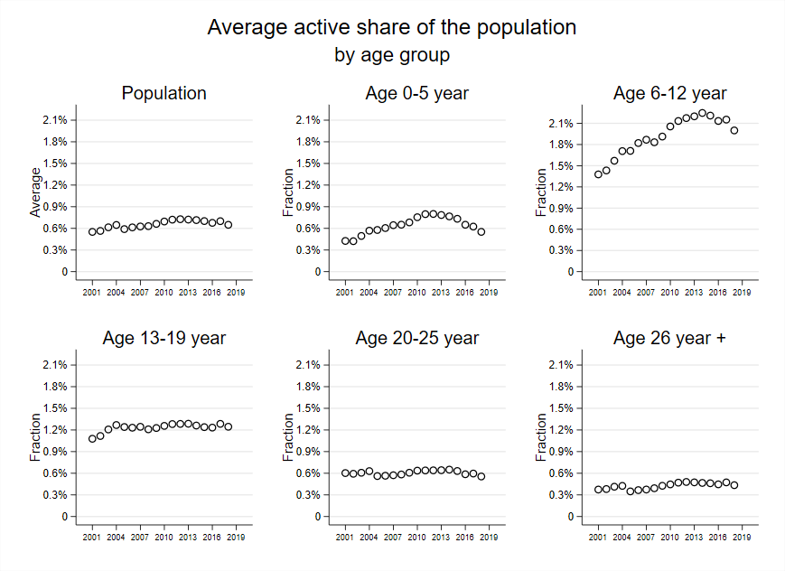

The active share in the age group from 0-25 is nearly three times larger than in the age group from 26 and above. In appendix figure 4B, the average active share of the population across all municipalities and federations for the two different age groups is represented.

## Variable description and variable creation

Table 2 Variable description and notations

|  |  |  |  |
| --- | --- | --- | --- |
| Variable name | Description | Equation | Notation |
| Id | Each observation has a unique id number |  |  |
| Year | Years of observation from 2001 to 2018 |  | t |
| Knr | Each municipality has their unique id number |  | k |
| SF | The 52 different sports federations |  | s |
| activity0_5 | Number of active sports members per federation across municipalities and years in the age group 0-5 years |  | A|0-5 |
| activity6_12 | Number of active sports members per federation across municipalities and years in the age group 6-12 years |  | A|6-12 |
| activity13_19 | Number of active sports members per federation across municipalities and years in the age group 13-19 years |  | A|13-19 |
| activity20_25 | Number of active sports members per federation across municipalities and years in the age group 20-25 years |  | A|20-25 |
| activity26_ | Number of active sports members per federation across municipalities and years in the age group 26 years + |  | A|26+ |
| activity0_25 | Number of active sports members per federation across municipalities and years in the age group 0-25 |  | A|0-25 |
| tot_activity | The total number of active sports members per federation across municipalities and years. |  | A |
| agegr0_5 | Population in the age group 0-5 years |  | P|0-5 |
| agegr6_12 | Population in the age group 6-12 years |  | P|6-12 |
| agegr13_19 | Population in the age group 13-19 years |  | P|13-19 |
| agegr20_25 | Population in the age group 20-25 years |  | P|20-25 |
| agegr26_ | Population in the age group 26 years + |  | P|26+ |
| agegr0_25 | Population in the age group 0-25 years |  | P|0-25 |
| Pop | The whole population in Norway |  | P |
| activeshare0_5 | active share of the population in the age group 0-5, per capita |  | Y|0-5 |
| activeshare6_12 | active share of the population in the age group 6-12, per capita |  | Y|6-12 |
| activeshare13_19 | active share of the population in the age group 13-19, per capita |  | Y|13-19 |
| activeshare20_25 | active share of the population in the age group 20-25, per capita |  | Y|20-25 |
| activeshare26_ | active share of the population in the age group 26+, per capita |  | Y|26+ |
| activeshare0_25 | active share of the population in the age group 0-25, per capita |  | Y|0-25 |
| activesharetot | active share of the whole population, per capita |  | Y |
| totfac_prtotCapita | The number of sports facilities available per capita of the whole population |  | FS |
| SFfac_prtotCapita | The number of sports specific facilities available capita for the whole population |  | GS |
| ComfacuniqePerCapita | The number of sports common facilities available capita for the whole population |  | CS |
| unemployment | Unemployment share of the population for each municipality over the years 2001 to 2018 |  | u |
| Totfac | The total number of sports facilities without any link to specific sports federations |  | F |
| SFfac | The total number of sports specific facilities with a link to a sports federation |  | G |
| Comfac | The total number of sports common facilities without a link to a sports federation |  | C |

**Regressors:**

Varying regressors across municipalities and years

Time-invariant regressors

Individual-invariant regressors

The purpose of the thesis is to investigate how the number of sports facilities per capita affect sports activity in sports clubs across the municipalities in Norway. For that purpose, variables that represent the active share of the population across municipalities from 2001 to 2018 are used as the dependent variable. The active share of the whole population, in each age group is calculated per capita, as shown in Equation 1.

Equation 1

The independent variable represents the number of sports facilities without any link to a specific sports federation per capita across municipalities for the period from 2001 to 2018, as shown in Equation 2. This equation is used in the regression to estimate the general effect of new sports facilities independently of which sport uses the facility.

Equation 2

A second independent variable is calculated for the total number of sports-specific facilities per capita across the municipalities for the period 2001 until 2018. The second independent variable calculated, as shown in Equation 3.

Equation 3

## 

## Model

The master thesis builds on repeated measures or longitudinal data (panel data) that allows controlling for unmeasured confounders. By using panel data, I limit the effects of bias and improve the causal estimation. (Gunasekara, Richardson, Carter, & Blakely, 2013) The research question builds on what more sports facilities affect the active, organized sport in Norway. To understand which variables that affect active sports members, there are most likely some measurable variables like active sports members in sports clubs. However, many different variables cause peoples to choosing to be active in sports in general and to be an active member of a sports club. The fixed-effects model has the advantage of reducing the impact of unmeasured characteristics that affect the activity in sports clubs, and is confounded by time-invariant factors (Gunasekara, Richardson, Carter, & Blakely, 2013).

The panel data allows creating models that describe municipalities' behavior both across time and across municipalities, and the dataset is represented both by within- municipality and between-municipality effects. The between-municipality confounders represent both observable and unobservable variables between the municipalities. Some of the unobserved confounders for the between-municipality effects may affect the activity variable, like the municipality economy, in which part of the country, a city or small town on the countryside (Breivik & Rafoss, 2017). The time-invariant factors for the within-municipality effects are measurable effects, like the number of inhabitants and the number of active sports members which change over time. Regarding time-invariant effects there are as well unmeasurable effects like welfare, education, the diverse sports interests and new technology that captures a person's interests, such as tablets. One of the significant factors which impacts the ability to join in sports, are social class in Norway (Breivik & Rafoss, 2017). Interactive gaming for children and youth are as well a competitor to sports activity in sports clubs. From early 2000 gaming has had an increasing interest for children and youth, and there are indications that gaming affects children’s activity and health (Graven, 2012). There are some milestones for new technology that may affect activity, like Nintendo DS in 2004 and the tremendous popularity of Minecraft from 2010, which still is a famous interactive game in 2020. In the fixed-effects model these effects will be canceled out from the time-fixed effects.

In Table 3 the summary statistic for the variables used in the model are shown, and both the within and between variation are shown. The overall variation is the variation over time and municipality. The between variation is the variation between the municipality and the within variation are variation within municipality over time.

Table 3 Summary statistics

|  |  |  |  |  |
| --- | --- | --- | --- | --- |
|  |  | **Mean** | **Std. Dev.** | **N/n/T-bar** |
| **Total activity** (tot_activity) | Overall | 72.6367 | 405.0547 | N = 243682 |
|  | Between | . | 393.1993 | n = 13653 |
|  | Within | . | 95.8347 | T-bar 17.8482 |
| **Total active share** (activesharetot) | Overall | .0066 | .02225 | N = 243682 |
|  | Between | . | .01998 | n = 13653 |
|  | Within | . | .0099 | T-bar 17.8482 |
| **Total number of facilities** (Totfac) | Overall | 39.3137 | 52.3110 | N = 243682 |
|  | Between | . | 51.9916 | n = 13653 |
|  | Within | . | 5.1506 | T-bar 17.8482 |
| **Number of facilities per capita** (totfac_prtotCapita) | Overall | .0071 | .0050 | N = 243682 |
|  | Between | . | .0049 | n = 13653 |
|  | Within | . | .0009 | T-bar 17.8482 |
| **Number of sports specific facilities per capita** (SFfac) | Overall | .8072 | 3.5753 | N = 243682 |
|  | Between | . | 3.5507 | n = 13653 |
|  | Within | . | .38848 | T-bar 17.8482 |
| **Total number of sports specific facilities** SFfac_prtotCapita | Overall | .0002 | .0006 | N = 243682 |
|  | Between | . | .0006 | n = 13653 |
|  | Within | . | .0001 | T-bar 17.8482 |
| **Total number of sports common facilities** (Comfacuniqe) | overall | 4.3002 | 11.8412 | N = 243682 |
|  | between | . | 11.7953 | n = 13653 |
|  | within | . | .9510 | T-bar 17.8482 |
| **Number of sports common facilities per capita** (ComfacuniqePerCapita) | overall | .0007 | .0011 | N = 243682 |
|  | between | . | .0011 | n = 13653 |
|  | within | . | .0002 | T-bar 17.8482 |

All the variables collected in the summary statistics in Table 3 show that the between variation is significantly larger than the within variation. These differences are as expected. There are substantial differences in both area size, number of inhabitants, and each municipality economy. Every fifth year SSC releases a report where the Norwegian municipalities are grouped after e.g., the number of inhabitants and economy (Kringlebotten, Langørgen, & Thorud, 2020).

The random-effects model may introduce confounding bias if unmeasured time-invariant variables affect both the dependent and the independent variables. The unmeasured time-invariant variables in this study must affect the active share of the population and the number of sports facilities. On the other hand, the fixed-effect model uses the within individual estimations and is not affected by confounding from unmeasured time-invariant factors.

### The within estimator – fixed effect model

The fixed-effects model is often used in research to control for confounding, as “Kaufman 2008 notes that the within estimator, which relies solely on within-individual changes, eliminates confounding by all innumerable and unmeasurable influences” (Gunasekara, Richardson, Carter, & Blakely, 2013). The fixed-effects model removes all time-invariant confounding, and each municipality will act as its own control. The fixed-effect model is sometimes referred to as a “two-way fixed-effects model” since the model takes into account both the time-specific and the municipality specific effects. Using the fixed-effects model, that is especially useful in cases where there are important causes that affect the sports activity, which are hard to measure and that tend to change slowly over time (Morgan, 2013) Kaufman states that the fixed effects model does not control for other biases, such as reverse causation.

When applying a fixed-effects model to the given panel data, a linear causal model is used in which the dependent variable is represented as the active share of the population denoted as , for k municipality of N municipalities measured at time t predicted by time-varying and time-invariant fixed effects. The fixed-effect model key term is the municipality fixed-effects denoted as . The municipality fixed-effect is a term that varies across municipalities, but is constant over time. The municipality fixed-effect comes from unobserved variables that vary across the municipalities, but not over the years, as municipality economy, number of citizens, and size. Because of the multiple observations for each municipality, I have sufficient degrees of freedom to include dummy variables for the . (Morgan, 2013) The time fixed-effects denoted as control for variables that are constant across municipalities but evolve over time. Some of these variables that evolve can be e.g., increased use of the internet, interactive gaming, new equipment as tablets, and governmental funding of sports across municipalities increased over time. is an error term with a conditional mean zero given that is independent of the values of FS for the municipality in the past, present or future. The municipalities k assumes to be independent across municipalities and has a correlation within the municipality over the years and denoted as . In other words, the unobserved variables within a municipality as the municipality facility rents for the sports clubs remain the same within a municipality over the years. Across the municipalities as an example facility rent is assumed to be uncorrelated. The assumption lets the model capture all the unobserved abilities of municipality specific effects that affect activity such as rent, municipality size, municipality economy, and different municipality specific political guidelines of sports facility funding. = is the variable of interest and captures the effect of an increase in the number of facilities per capita. This means that the causal effect on activity in sports clubs is affected by the building of new sports facilities with changes across municipalities.

The linear fixed model is then:

Equation 4 =

Equation 4 allows estimating the general effect on how new sports facilities create more activity in the sports club. The model lets all sports facilities be available for all different sports. Many different sports have different needs to exercise their sport. First of all, some sports have the possibility to use multifunctional facilities and other general facilities, like gymnasiums. Second, a share of the sports needs concrete sports-specific facilities typically sports like swimming and shooting. Thirdly, some sports need sports-specific facilities, but also have the opportunity to perform their sport in more general sports halls, like gymnastics and athletics. The model in Equation 4 will give an indication of how a large amount of sports facilities has affected the activity in general, when assuming that all sports can use all sports facilities.

The collected facility data from the Ministry of Culture gives the opportunity to create a second equation for sports-specific estimations. The linked sports-specific facilities to their respective sport will estimate how new sports-specific facilities affect the activity. A fixed-effect model for the sports-specific estimations presented in Equation 5 is are similar to the Equation 4; the difference between the two models is the source of the number of sports facilities per capita. In Equation 5 the sports-specific facilities is counted for.

Equation 5 =

The facility data contains of both sport-specific facilities and common sports facilities, which in all are more “general” sports uses. Such sports facilities are e.u. multifunctional sports halls. In the final dataset all sports federations which do not have any sport-specific facilities linked are linked to the common sports facilities across the municipalities over the time period and are estimated as shown in Equation *6*

Equation 6 =

In the final model both the sports specific facilities and the sports common facilities are taken into account in the equation as, shown in

Equation 7 =

The fixed effects estimation does not require a random sample of the population where the dependent and the independent variable are independent of each other. When using a fixed-effects model, there may be a correlation between the independent and the dependent variable. It explained that the confounders might influence both the dependent and the independent variable (Gunasekara, Richardson, Carter, & Blakely, 2013). “As a result, the fixed effects approach is less prone to bias because its assumptions about unmeasured causes are more realistic than the assumptions that we usually need to make about those causes. We refer to this as the fixed-effects model advantage (Morgan, 2013)”. “ It is important to keep in mind that the fixed effects approach does not remove the biasing effects of time-varying confounders, so the key assumption of the method is that unmeasured causes are constant (Morgan, 2013)”.

The paper's research question is looking into what happens with the active share of the population if the number of sports facilities per capita increases. The number of sports facilities per capita is likely to correlate with the population's active share. As mentioned earlier, the standard deviation has both within and between variation. The fixed-effects model is used in the analysis.

### Municipality differences

Starting with a scatter plot of the dependent and the independent variable, shows that most of the data's observations have values between 0 and 0,5 for the active share per capita. The number of sports facilities available per capita ranges from above 0 and under 0,25 facilities. The scatter plot in appendix figure 7 shows that some of the active share observations are above 0,5 and with two different clusters. One cluster for the main observations and a small cluster to the right in the graph, which seems to be odd. The odd cluster or outlier in the scatter plot identified as a small municipality with fewer than 1000 inhabitants (Bykle[6]) with more than 0,040 number sports facilities available for each inhabitant in the municipality.

The same scatter plot from appendix figure 7 can be found in Figure 14, except that the scatter plot in Figure 14 represents just data from 2018, and the x- and y-axis have switched places.

The scatter plot shows a clear outlier in the upper left corner. The exact points are identified in the data as the municipality Bykle. Besides, the scatter plot shows some outliers with activity above 0,4 per capita. These three data points are three small municipalities with a large portion of active sports members in three

different sports federations.

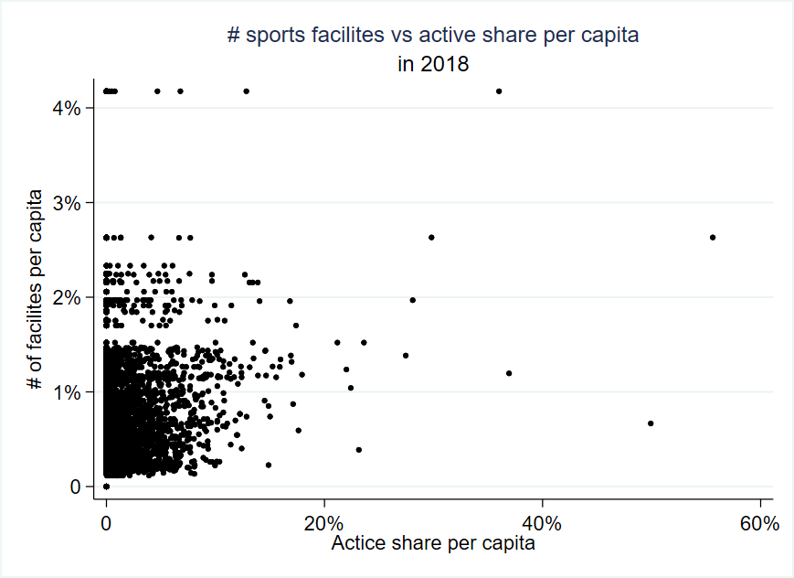

Figure 14 The scatter plot shows the number of sports facilities per capita in the y-axis and the active share of the population in the x-axis. The plot gives a clear indication of an outlier in the data. In the upper left corner, a cluster of points shown where the number of sports facilities per capita are more than 4% (Bykle) as shown in the y-axis.

By looking into just the “noise” of the data as shown in Figure 15, which contains data for the whole period some outliers with a high active share of the population are shown. Two odd data points to the right of the graph show an active share near around 100%.

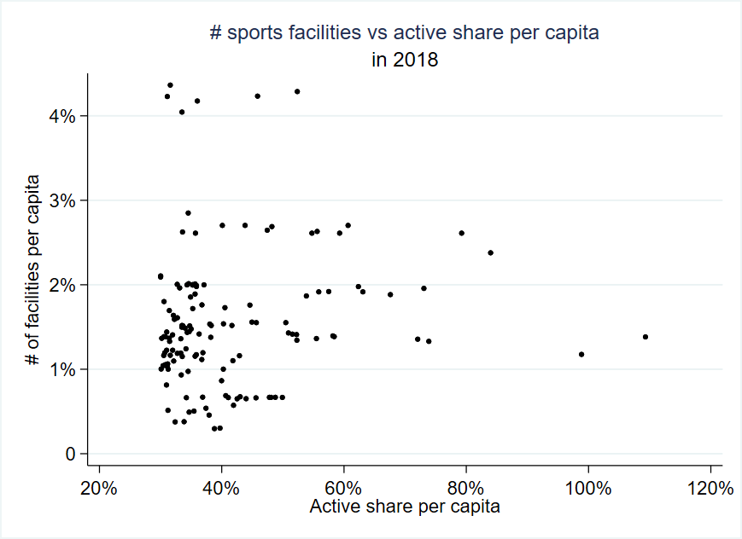

Figure 15 The scatter plot shows in the y-axis number of sports facilities per capita, and the x-axis represents the active share of the population. The data pointes represent the noise as shown in Figure 14.

These odd data point to the right in the graph may indicate that something is wrong with the data. Another explanation is that these municipalities have some big sports clubs that attract inhabitants from other municipalities to their sports clubs. The data from *NIF* has no information about the sports members home municipality, so there are error wedges in the data regarding an inhabitant’s home municipality and their sports clubs' municipality belonging.

The municipality Bykle with a higher number of sports facilities per capita than all other municipalities will be cancelled out in the fixed-effects model by the municipality fixed effects. The two odd data point are kept in the data, since a few datapoint do not have a significant impact on the analysis.

## Analysis

The fixed-effects model based on Equation 4 is used as a baseline model, where the coefficient of interest is the number of sports facilities per capita estimated across all municipalities over the period 2001 to 2018. If shows how the number of facilities per capita estimates the effect on the active share of the population in Norway. The estimations are based on all sport members in Norway and the whole Norwegian population. The independent variables are standardized and an increase in the number of sports facilities represent one standard deviation from the mean number of sports facilities per Norwegian inhabitant. The baseline model represents an estimation of the effect of both the sports specific and the common facilities, in Norway. The variable “# of sports Facilities per capita” can be interpreted as for every increase of sports facilities in general by one standard deviation, the active share of the population increases by the coefficients represented in percentage points. The baseline model estimate indicates that by increasing the number of sports facilities by one standard deviation from the mean the active share of the population might increase by 0.19 percent points. The results from the baseline model are significantly estimated with a p-value less than 0.001, which means that there is a positive effect by building new sports facilities.

The collected data contains three different variables regarding the number of sports facilities. In the baseline model the total number of facilities are considered. In Table 4 the baseline model are compared with estimates for the variable of sports-specific facilities and the common sports facilities. Both variables are standardized, and in the last model in Equation *7*  = both the common and the sports specific facilities are represented.

As explained in the chapter “Data”, some sports-specific facilities have been possible to match with a respective sports federation. The complete list of how the sports-specific facilities matched each sports federation are shown in appendix table 6. Not all sports need sport-specific facilities because they can perform their sport in e.g., multifunctional halls. For that reason, these sports have not been matched with a sport-specific facility. However, all sports federations which do not use sport-specific facilities, are linked to a common facility, like multifunctional sport halls. For the estimated models I assume that sports federations with a linked sport-specific facility just use these facilities. All sports federations without any sport-specific facility, assumes to use just the common sports facilities.

### Model estimations

Table 4 Model estimations for the four defined equations

|  |  |  |  |  |
| --- | --- | --- | --- | --- |
|  | **Baseline** | **Specific** | **Common** | **Both** |
|  | Active share | Active share | Active share | Active share |
| # of sports Facilities per capita level (totfac_prtot  CapitaST) | 0.00194*** (0.00039) |  |  |  |
| # of sports specific Facilities per capita level (SFfac_prtotCapita) |  | 0.00188*** (0.00044) |  | 0.00190*** (0.00044) |
| # of common Facilities per capita (Comfacuniqe  PerCapitaST) |  |  | 0.00109 (0.00069) | 0.00113 (0.00069) |
|  |  |  |  |  |
| *N* | 243682 | 243682 | 243682 | 243682 |
| *R*2  Within  Between  **Overall** | 0.0040  0.0020  0.0022 | 0.0037  0.2239  0.1737 | 0.0035  0.0049  0.0004 | 0.0042  0.2219  0.1721 |
| *Time fixed effects* | Yes | Yes | Yes | Yes |

Standard errors in parentheses with clustered at mean level

* *p* < 0.05, ** *p* < 0.01, *** *p* < 0.001

Every Norwegian inhabitant has on average 0.0002 sports-specific facilities available as shown in Table 3, compared to the common sports facilities, which are available on average per capita by 0.0007. The fixed-effect model with the independent variable as the sport-specific facilities (Specific), estimates the effect of the number of sport-specific facilities has on the active share of the population. The model estimates for every increase of the number of sport-specific facilities by one standard deviation. The active share of the Norwegian population increases by 0.188 percent points, with a significant level of a p-value less than 0.001 and has the same statistical significant p-value as the baseline model. Both the baseline model and the sports-specific (Specific) model create estimates within a

95% confidence interval, with a small standard error. This indicates that all the coefficients are clustered around the slope.

The common sports facilities are linked to sports where there are no special needs to the facility. The estimates from the model “Common”, indicates by every increase in the number of common sports facilities by one standard deviation the active share of the population increases by 0.109 percentage points. These estimates are not significant within a confidence interval of 95%. Since the estimations are not statistically significant, there is no statistical evidence that the population's active share will increase by the estimated rate when common sports facilities are considered.

By taking into account both the variables specific and common facilities as shown in Equation *7* = . The estimated coefficients for the sports specific facilities are still statistically significant within a confidence interval of 95%. The coefficient value itself increases slightly. The same counts for the variable of the common sports facilities. They are still not significant, and the estimates cannot statistical verify rate, but it indicates an increase of the active share of the population.

Another statistical value must be taken into account when evaluating the quality of the model is . The overall quality means how well the model tracks the actual data (Jank, 2011). Comparing the four different estimates from Table 4, the estimates where the sport-specific facilities alone are calculating the effect; the are highest for this model. By using Equation *5* to estimates the effects, 17,37% of the data are explained by the model. A proper percentage depends on the context. In some cases, a of 17,37 % are poorly explained models, and in other cases, like social scientists or business executives, a around 20% to 25% are pretty good. In e.g., social sciences, it is tough to control extraneous factors, such as in this master thesis where I measure human’s choice to participate in organized sports activities (Jank, 2011).

A conclusion of the four different estimations shows that the sports specific model is the most reliable model to use when explaining how the number of sports facilities affects the active share of the population as an overall estimation.

### Sports federation coefficients

The variable for the sport-specific facilities will be used in following analysis and contains estimations for the sports federations, which have a sport-specific facility linked. The fixed-effect model is used to estimate coefficients for each sports federation separately. In Appendix table 8, a complete list of all sports federations and their statistical means and standard deviations for the dependent and the independent (sports specific facilities per capita and sports common facilities per capita) values is shown, with a mean level clustered around the municipalities. As explained in the chapter

Sports federation differences” there are significantly differences between the different sports federations and their active share of the population. The average active share of the population for the five largest sports federations are football 6.2%, skiing 4.8%, handball 1.5%, golf 2.1%, and gymnastics with 1% of the population in Norway. Football, skiing, golf and gymnastics are some of the sports federations with sport-specific facilities linked.

Figure 16 illustrates each sports federation associated coefficient, and the calculated numbers can be found in appendix table 9. The figure gives a clear picture of how each federation is affected by every increase in the number of sports specific facilities for their sport, by one standard deviation from the mean. The coefficients indicate that nearly all federations have a positive effect of an increase in the number of sport-specific facilities. The coefficients confidence interval is indicated by the straight-line trough the dots in the graph.

Five different sports federations which the model estimates statistical significantly coefficients are golf (*** *p* < 0.001), climbing and sailing (** *p* < 0.01), and gymnastics and skating (* *p* < 0.05). Figure 16 show that all the estimated coefficients with the

highest values have a larger variation around the slope than the smaller estimated coefficients. The standard error tells how the variation are around the slope, or how much noise around the estimated coefficient (Jank, 2011). By comparing the five sports federations which has significantly estimated coefficients with p-values within a confidence interval of 95% I find that there are some variations between the five sports federations regarding the noise around the coefficients.

Figure 16 Each sports federations coefficient from the fixed effects model when the sports specific facilities are considered. In the y-axis are the different sports federations represented and on the x-axis the value of the coefficient shown as a dot. The confidence interval represented by a straight line through the dot.

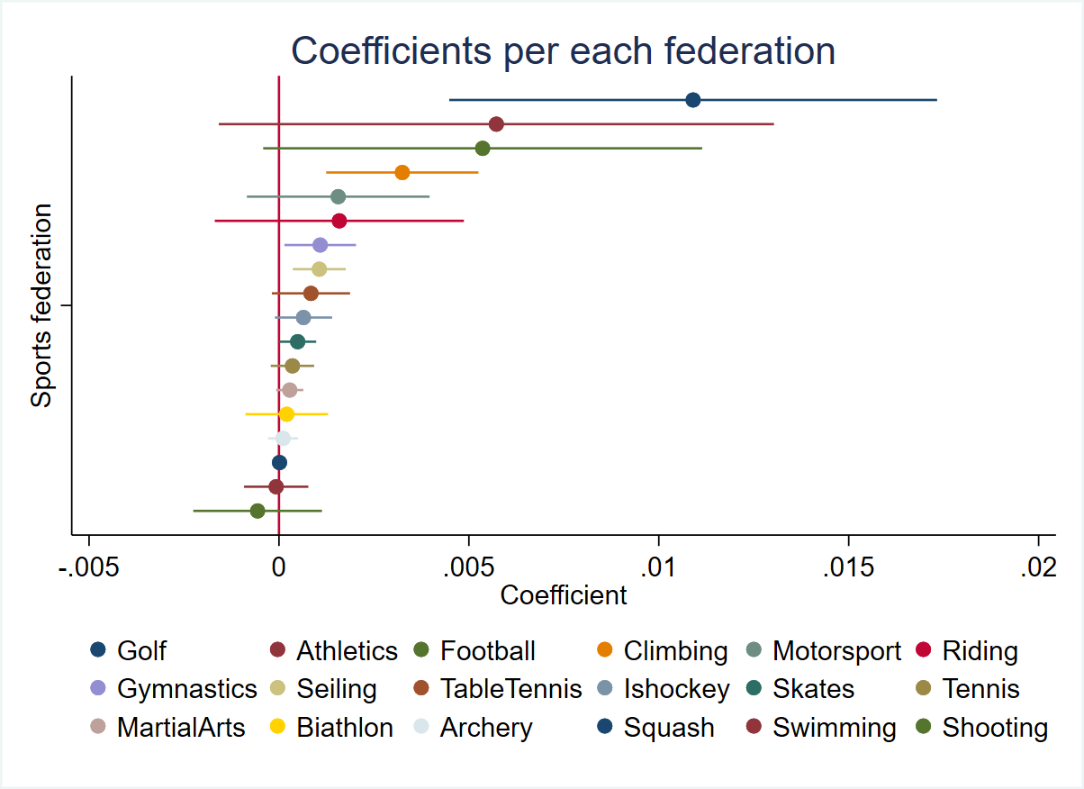

Golf***ing

Climbing**ing

Gymnastics*

Sailing**ing

Skates*ing

Martial Arts

For every increase of the number of golf courses per capita by one standard deviation, the model indicates that the active share who participates in golf increases by 1,09 percentage points. By looking into the 95% confidence interval, the coefficients vary around the slope between 0,44 to 1,73 percentage points, which means that the effect of a new golf course shows small variations around the coefficient. From 2001 to 2010 there has been a continually increase in the

actual number of golf courses but from 2010 just a few courses have been built. This might indicate why the actual number of golf players are reduced, and an increase in the number of golf courses might increase the activity again.

Gymnastics has an estimated coefficient with a statistically significant within a confidence interval of 95% with a p-value of 0.024. The model estimations for every increase in the number of sports facilities per capita by one standard deviation, the active share of the population who participates in gymnastics by increase by 0,11 percentages points. The standard error is 0,05 which tells that noise around the slop is tight. This must be seen in the light of that from 2007 to 2018 there has been built approximately 35[7] new gymnastic halls in different part of Norway. The halls might have had a good impact in the specific municipalities where they are built.

Appendix picture 10 gives a picture of how variated golf and gymnastics are compared to each other. Gymnastics had 507 sports clubs in 2018 and golf had 160. The map show that gymnastics are represented in nearly all municipalities, unlike golf, which is represented in less municipalities than gymnastics and has significantly less sports clubs represented.

The coefficient for climbing shows that for every increase in the number of climbing facilities per capita by one standard deviation, the active share of the population who participates in climbing, increases by 0,32 percentages points, within a confidence interval between 0,12 to 0,53 percentages points. Sailing has an estimated coefficients of 0,11 percentages points. So, by every increase in the number of sailing facilities by one standard deviation, the active share of the population in Norway who participates in sailing increases by 0,11 percentages points. The variation around the slope for the estimated sailing coefficients, varies

between 0,36 and 0,18 percentages points. The Norwegian Skating Federation represents the smallest statistically significant estimated coefficient. For every increase in the number of skating rinks by one standard deviation, the active share of the population who participates in skating increases by 0,05 percentages points.

The estimated coefficients for the rest of the different sports federations from Figure 16 can be found in appendix table 9. All of the other sports federations have a positive effect by increasing the number of sports facilities belonging to their sport except swimming and shooting.

The overall estimations for how new sports specific facilities affect the active share of the Norwegian population are presented in Table 4 column 2. For each increase of the number of sports specific facilities by one standard deviation, the active share of the population in Norway increases by 0,19 percentages points.

### New sport-specific facilities and development of the number of sports members

In the next paragraphs I will investigate in particular on how more sport-specific facilities affect the number of active sports members in different municipalities and different sports: climbing, athletics, gymnastics and martial art. I have picked two of those federations on which the fixe-effects model has estimated the highest effects (Athletics and Climbing), gymnastics is in the middle of the estimated coefficients and martial art has one of the smallest coefficients (the coefficients can be found in Figure 16). Out of these four sports federations I have randomly picked municipalities which have built a new sport-specific facility in the period 2003 to 2016, and looked into how the number of active sports members in each sports federations was five years before and five years after the facility came through.

*Climbing*

The Norwegian climbing federation is among the younger sports federations in Norway established in 1992 (Norges Klatreforbund, 2020). The fixed-effect model estimates an increase active share of the population by 0,32 percentage points for every increase in the number of climbing facilities by one standard deviation. In the graphs below I have randomly picked five different municipalities which are different both in number of inhabitants and in which part of Norway they occur.

Figure 17 The three municipalities of Averøy, Rana and Tønsberg has built new climbing facilities within the period from 2003 to 2016. The graphs show how the actual activity in climbing had developed five years before and five years after the facility came. The x-axis stands for years before and after a new facility were established in each municipality. The y-axis represents the number of sports members in the Norwegian climbing federation.

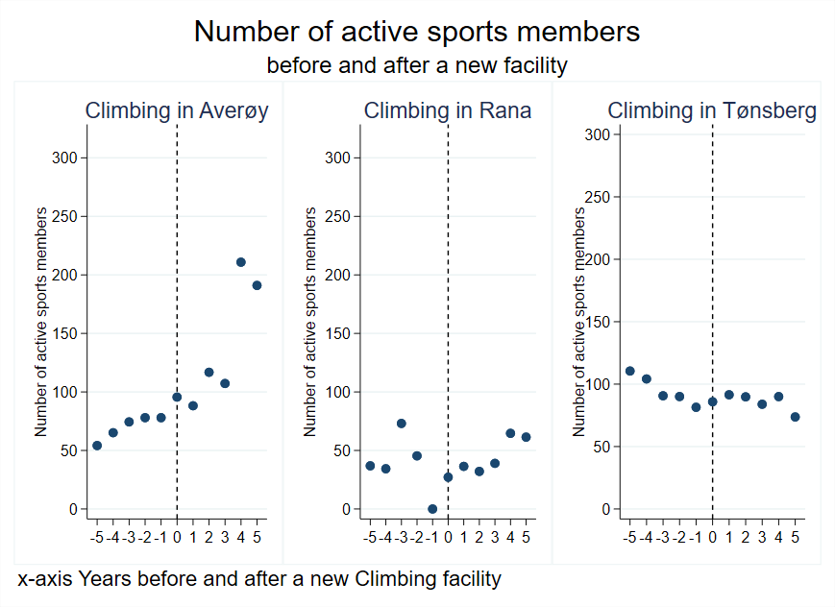

Figure 17 shows the municipalities of Averøy, Rana and Tønsberg are represented by the number of active sports members in climbing five years before and five years after a new climbing facility came through. The graph shows that Averøy and Rana had a significantly increase in the actual number of active sports members. Tønsberg is a larger city and had a smaller increase in the number of active sports members after the facility came through.

Figure 18 shows the number of active sports members in climbing in the municipality of Trondheim and Bergen, two of the nine largest cities in Norway. When Trondheim got a new climbing facility, it gave an instant increase in the activity the first year after the facility was built, but the high activity did not last more than three years. From the fourth year the activity dropped. Bergen painted a different picture. The number of climbing members in Bergen had a constant increase the three years before the facility was built and had a significant jump in increased number of climbers from the second year after the facility came through. The activity trend in Bergen

that there has been an increased activity before the facility came which, indicates the need of climbing facilities.

Figure 18 The two municipalities of Trondheim and Bergen which is two of the nine largest cities in Norway. These municipalities built new climbing facilities within the period from 2003 to 2016. The graphs show how the number of active members in climbing had developed five years before and five years after the facility came. The x-axis stands for years before and after a new facility were established in each municipality. The y-axis stands for the active sports members in the Norwegian climbing federation.

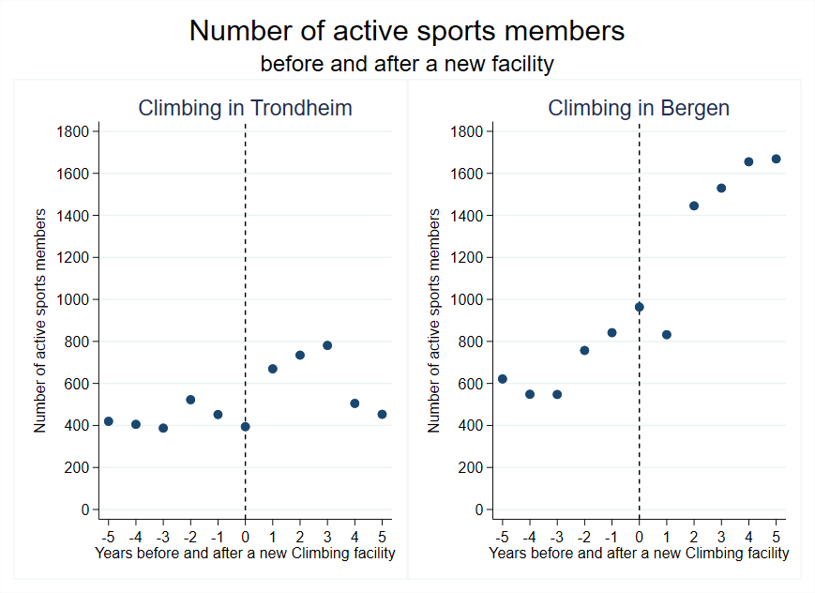

*Athletics*

The Norwegian Athletics Federation is one of the sixth largest sports federations in Norway and among the oldest sports federations. The Norwegian Athletics federation was established in 1896 (Store Norske leksikon , 2020). The fixed-effects model estimates that by increasing the number of athletic facilites by one standard devitaion the active share of the population who partisipates in athletics increses by 0,57 persentage points, which is one of the largest estimated effects.

Oslo is the largest city in Norway, and atletics have a significant higher number of active sports members than other municipalities. Appendix figure 12 shows the development of the number of activ sports members five years before and five yeares after a new athletics facility was built in Oslo are shown. The graph shows a continoues trend of increased activity in the five years before the new facility came, and the fourth yeare after the facility was built, the activity had a significant increase the third year.

Bergen and Bærum as well, have established new athletics facilities in the period from 2003 to 2016. Figure 19 shows the development for athletics in the two municipalites. Bergen increased their number of active atheltics members the second year by nearly 500 members. Bærum experienced an increase in their number of active sports members the third year after the facility came through. The fourth year the number of active members had incresed by nearly 500.

Figure 19 The two municipalities of Bergen and Bærum. Bergen is one of the nine largest cities in Norway and Bærum is a large municipality. These municipalities built new athletics facilities within the period from 2003 to 2016. The graphs show how the actual activity in athletics had developed five years before and five years after the facility came. The x-axis represents years before and after a new facility were established in each municipality. The y-axis stands for the active sports members in the Norwegian athletics federation.

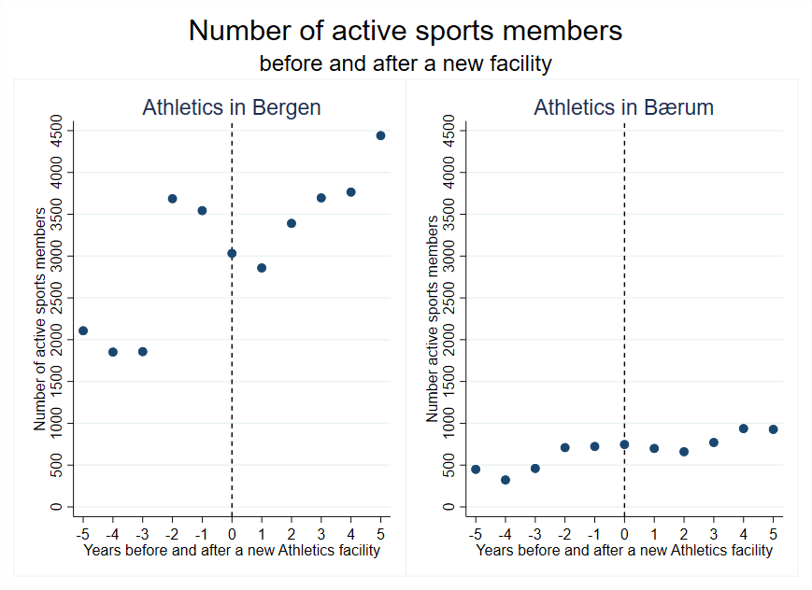

Appendix figure 13 shows four large municipalites (Arendal, Asker, Kristiansand and Tønsberg) and one medium sized municipality, which has built a new facility in their municiaplity. Tønsberg and Asker are the two municipalities experiencing an increase in the number of sports members after the new facility came. Arendal and Kristiansand have an increasing trend in the number of sports members before the new facility came but experiencing a decrease in the number of sports members in the years after. The municipality of Lunner, the new facility, does not seem to affect the number of sports members of any importance.

*Gymnastics*

The Norwegian Gymnastic Federations is the first sports federations, established in Norway in 1890 (Store Norske leksikon , 2020) and the fifth largest sports federations in Norway. The estimates for the fixed-effects model indicates that by increasing the number of gymnastic halls by one standard deviation the active share of the population increases by 0,11 percentage points.

In Figure 20 the three municipalities of Asker, Bergen and Oslo are presented. Bergen and Oslo are among the nine largest cities in Norway and Asker is a large municipality nearby Oslo. These three municipalities have built new gymnastics halls in the period from 2003 to 2016. The graph creates a picture of how the number of active gymnastics members has developed the five years before and after the new facility was established. Asker had a rising number of active sports members in the five years before the facility was built, which indicated the need of a gymnastic facility in the municipality. Unfortunately, it seems that the new facility did not created even more active gymnasts in the municipality. Bergen had a slow increasing trend of the number of gymnasts five years before the new facility, and after the new facility came, the increased number of active gymnasts has increased significantly more than the first five years.

Oslo is the capital of Norway and holds the largest sports club in Norway if you exclude the sports club for students in Norway, which is Oslo Turnforening. Figure 20 shows that the number of active sports members in gymnastics in Oslo has had a significantly increase the five years before the new facility came, and even a higher increased number of active sports members after the new facility came through.

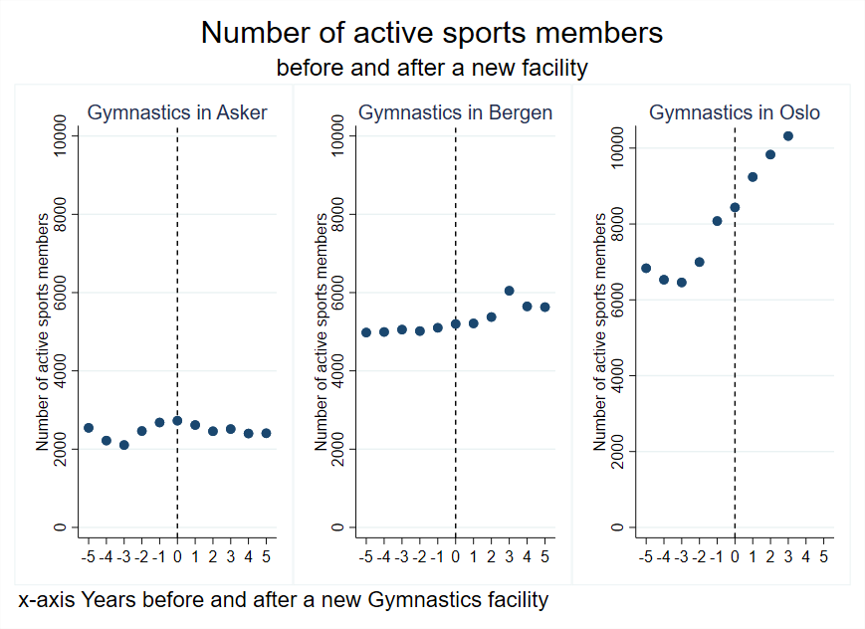

Figure 20 The three graphs represents the municipalities of Asker, Bergen and Oslo. These municipalities built new gymnastic facilities within the period from 2003 to 2016. The graphs show how the number of active sports members in Gymnastics had developed five years before and five years after the facility came. The x-axis represents years before and after a new facility were established in each municipality. The y-axis stands for the number of active sports members in the Norwegian Gymnastic federation.

The municipality of Arendal got a new gymnastic hall in 2012. The first graph in Figure 21 shows how the number of active sports members in gymnastics has developed the five years before and after the new facility came. The year the new gymnastic hall was ready to use, the number of active gymnasts had a significant increase from approximately 450 members to nearly 650 members the year the facility came. The number of active sports members has as well increased the five years after the facility came. Both Tønsberg and Fjell had a trend of increased number of active sports members the years before the new facility came. Tønsberg had an instant significantly increase number the first year after the new facility came. The municipality of Fjell had an increasing trend the five years before the new facility came, and the third year after the facility came through, the number of active gymnasts had a significant increase.

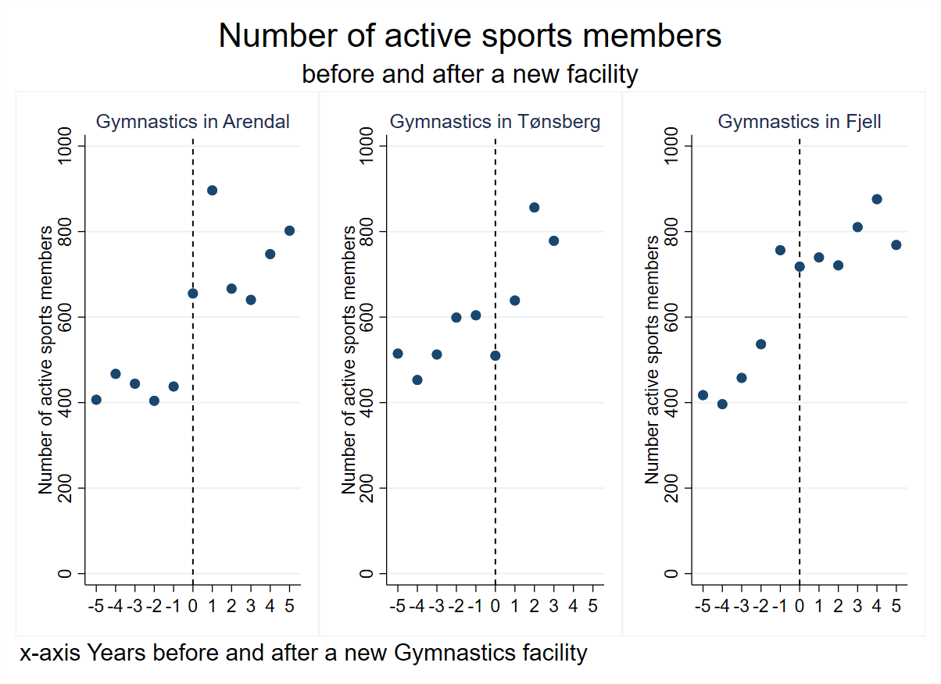

Figure 21 The three graphs represents the municipalities of Arendal, Tønsberg and Fjell. These municipalities built new gymnastic facilities within the period from 2003 to 2016. The graphs show how the number of active members in gymnastic had developed five years before and five years after the facility came. The x-axis represents years before and after a new facility were established in each municipality. The y-axis stands for the number of active sports members in the Norwegian gymnastic federation.

The final graph illustrates the changes in number of active sports members in gymnastics in the municipalities of Lunner and Ringerike and are found in appendix figure 14. Both municipalities built a gymnastic facility in the period from 2003 to 2016. The graph for the municipality of Lunner shows that the number of active gymnasts the five years before the new facility came had a slightly decline, but the first year after the new facility came, the municipality had a significantly increased number of active gymnasts. Ringerike had a different change regarding the new facility. This municipality had a decline in active gymnasts the three years before the new gymnastic hall came, but did not experience an increase before three years after the facility came through.

*Martial arts*

The Norwegian Martial Arts Federation were established in 1973 and is among the 10 largest sports federations in Norway. The estimated coefficients from the fixed-effects model indicate that by increasing the number of sports facilities customized martial arts by one standard deviation, the active share of the populations who participated in martial art increased by 0,03 percentage points, and is among the smallest coefficients estimated from the fixed-effects model.

Since martial arts are less widespread than the other sports commented above, I have picked five different municipalities, Bærum, Kristiansand and Oslo as investigated in the other federations. In addition, Ringrike and Tønsberg are investigated.

Figure 22 The three graphs stands for the three large municipalities Bærum, Kristiansand and Oslo. These municipalities built new martial arts facilities within the period from 2003 to 2016. The graphs show how the number of active members in martial arts had developed five years before and five years after the facility came. The x-axis stands for years before and after a new facility were established in each municipality. The y-axis stands for the number of active sports members in the Norwegian martial arts federation.

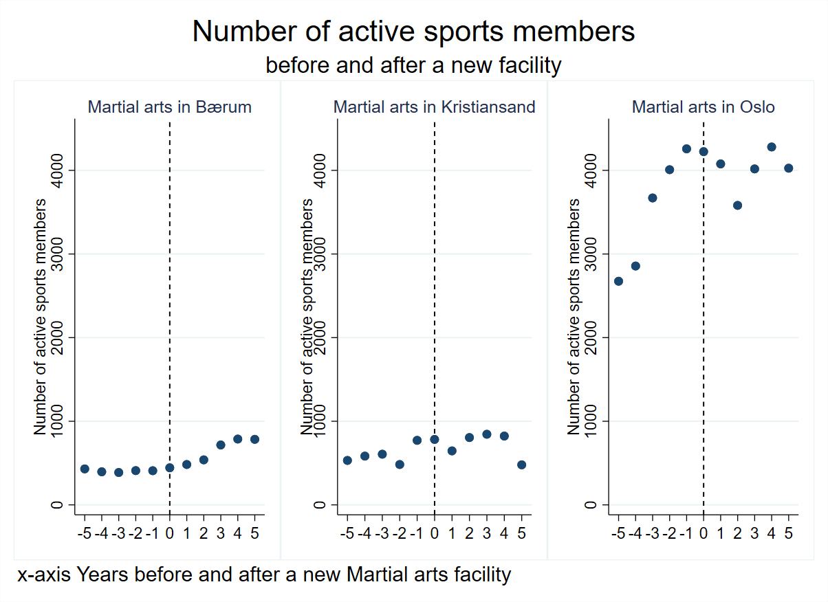

Figure 22 shows the number of active sports members in martial arts in each of the municipalities are shown. Kristiansand seems to have a small effect from the new facility the second year, but the number of sports members drops the fifth year. Oslo had a significantly increasing number of sports members the five years before the new facility came, but has not experienced a growth in the number of sports members after the facility came. On the other hand, Bærum had a steady number of active sports members before the new facility came through, and in the five next years they experienced a significantly increase in the number of active sports members.

Appendix figure 15 shows how the number of sports members in martial arts five years before and one to three years after a new martial art facility was built in the respective municipalities. Both municipalities had an increasing trend in the number of active martial arts members. Ringerike got the new facility in 2017, and the activity decreased slightly in 2018. How the effect of the new facility in Ringerike will be are too early to state. The municipality of Tønsberg had an increasing trend of the number of active sports members the four years before the new facility came. The second year after the facility was built in Tønsberg it seems to create an increase in the number of active martial art members.

### Summarizing the assessments of the federation effects

It is time to summarize how the effects of new facilities have been on the different sports federations in the randomly chosen municipalities I see that new facilities for use in climbing have a significant impact on the number of sports members. In athletics the large cities have large effects, than in large and medium municipalities. The change in these municipalities is lower. In gymnastics the larger cities affect less from new facilities than large and medium sized municipalities regarding a percentage increase. However, in total number of active sports members in the larger cities engage a higher number than the large and medium municipalities. In martial arts the effects of new facilities go from variations between decrease to large effects. A schematic picture of the effects are shown in Table 5.

Table 5 Summarizing the effects from the differed municipalities and the different sports federations.



### Multifunctional sports facilities

SSB's report from 2018 regarding the development of sports facilities states that from 2014 there has been an increase in building multifunctional facilities in Norway (SSB, 2018). The facility register from the Ministry of Culture gives an overview of all multifunctional sports facilities and their construction year. Out of SSB’s categories of municipalities, I have randomly picked one municipality from the categories large, medium and small (Kringlebotten, Langørgen, & Thorud, 2020) where a multifunctional facility was built in 2012 and 2014.

Using such a selection and looking into how the total activity has developed after a multifunctional sports hall is built, will indicate how a multifunctional sports hall affects sports activity in sports clubs in that municipality.

In the largest municipality - Arendal, a multifunctional sports hall combined with a new high school which opened for sports activity in 2012, with facilities like tennis, gymnastics, handball, climbing, football and volleyball courts (Sør Amfi turnanlegg) (Gode idrettsanlegg, 2020).

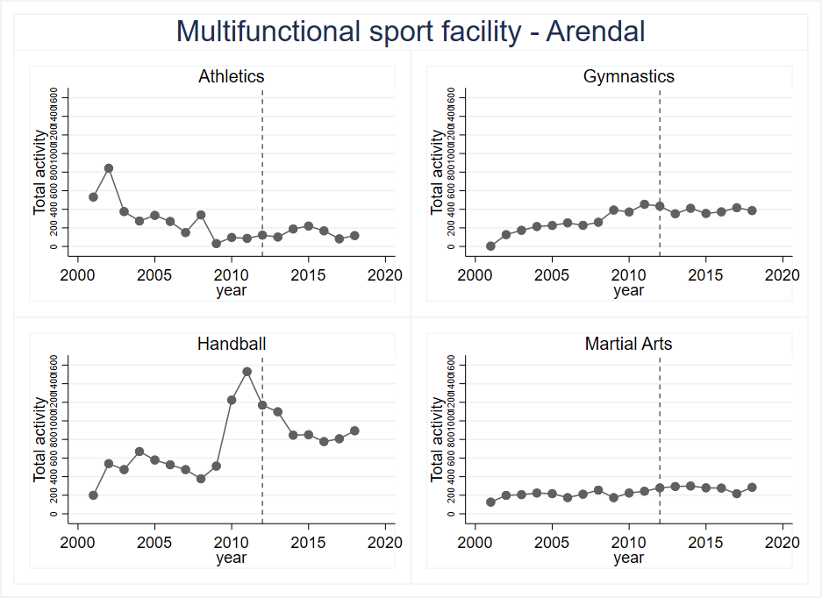

Figure 23 illustrates the number of active sports members in a large municipality where a multifunctional sports facility built in 2014. In the y-axis the number of active sports members in sports clubs. The vertical dotted line shows the year where the new facility came through.

The two main sports activities which use the new arena the most are handball and gymnastics. Figure 23 shows how the number of active sports members in the municipality of Arendal has developed the last 18 years, and in appendix figure 12 all federations are shown. Handball had a significant increase from 2008 until a top in 2011. After the new arena came through in 2012, there has been a decline in the activity. Gymnastics has had a continuous increase from 2009 until a dip in the activity in 2017, before again you find an increase. By looking into the average numbers of sports members in the four sports in Figure 23, in the eight years before the new facility and eight years after the new facility, the average number of actual sports members has increased for all the sports, except athletics. The increased average active sports members indicate a shift in the trend in the activity in the municipality of Arendal.

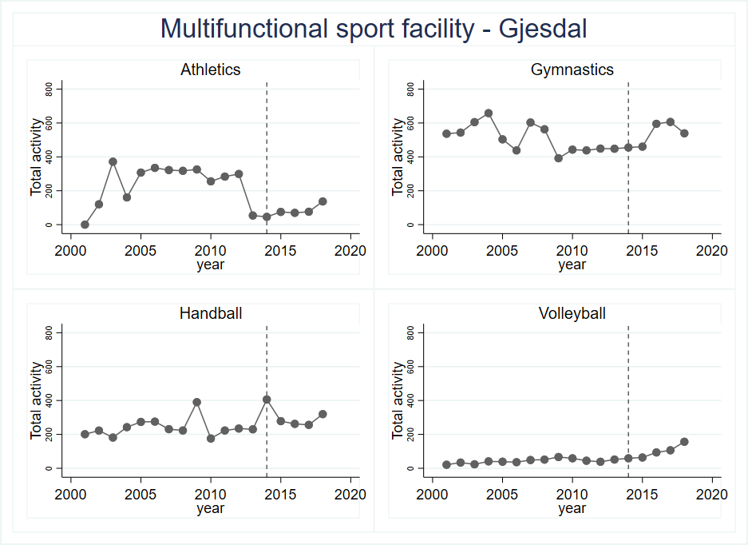

Figure 24 illustrates the actual activity in a medium municipality where a multifunctional sports facility built in 2014. In the y-axis the actual active sports members in sports clubs represented. The vertical red line indicates the year where the new facility was ready for use

In the medium municipality of Gjesdal in the south-west of Norway, a multifunctional sports hall was built in 2014 and ready for use in April 2015 (Stavanger, 2015). Compared to the large municipality, the medium municipality has fewer sports federations represented in their municipality (all sports federations active sports members development can be found in appendix figure 12). The largest sports federations which use a multifunctional sports hall are athletics, gymnastics, handball, and volleyball. Dirdal sports club offers sports like handball and gymnastics in the facility.

Figure 24 shows how sports like athletics, gymnastics, handball and volleyball has developed in the number of active members the last 18 years. The dotted vertical line in the graph shows the year the new sports facility “Dirdalhallen” got available in the municipality of Gjesdal. Athletics, gymnastics and volleyball have had a minor increase in the number of sports members as opposite to handball, which had a decline the three first years after the facility came. However, from 2017 the number of active handball players increases again. By looking into the average active sports members in the 4 following years and compare them with the four previous years of the new facility, the average active members increase in all the sports from Figure 24, except athletics, which has a decrease.

In the end, the small municipality of Steigen far north in Norway, a multifunctional sports facility came through in 2014, and the first users started in the autumn of 2014 with their activities. The new facility CEO was looking forward to filling the shooting room material art room, and the sports hall with activity. They wished to be able to offer different new sports to the community, as handball, basketball and volleyball. The new facility gives possibilities as well for football, dancing, and badminton. (Olsen, 2014).

In Figure 25, the four sports who normally uses multifunctional halls in this small municipality show how the development of each sports federation’s register sports members has developed since the new facility came (a complete overview of all sports federations can be found in appendix figure 12). Volleyball and Handball got an immediate increase in their activity. Athletics had a small dip in the second year after the new facility became a reality, but increased the third year. However, how these trends will develop the next years, might give an answer to what effect the new multifunctional facility has created.

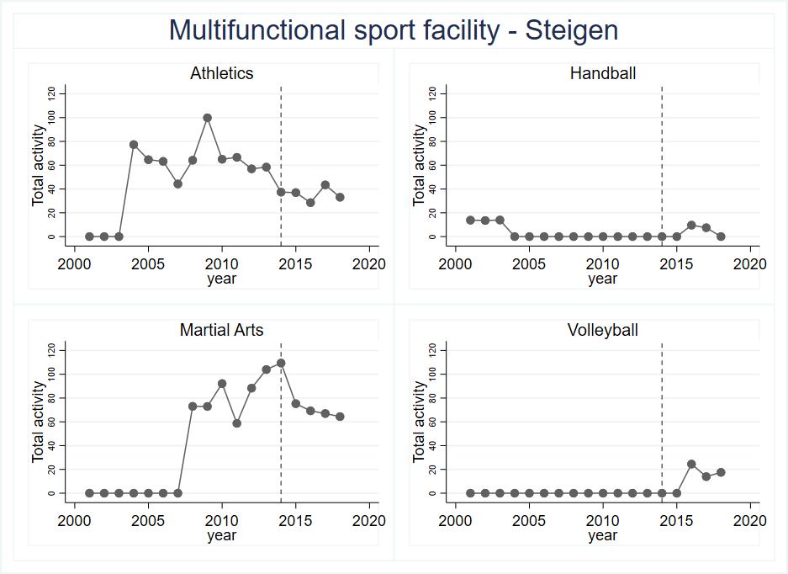

Figure 25 illustrates the actual activity in a small municipality far north in Norway where a new multifunctional sports facility built in 2014. In the y-axis the actual active sports members in sports clubs represented. The vertical red line indicates the year indicates the year where the new facility was ready for use

The only sport that has had a negative trend after 2014 and the new facility, is martial arts. Martial arts continued to decrease from the top in 2014 until 2018. In the two sports athletics and martial arts, which had activity before the new sports hall came, had on average a higher number of active members than after the facility came.

To sum up of the deep dive into the analysis of the multifunctional sports facilities in a large, medium and small municipality, I find that some trends show that the number of sports members in some sports federations have a slightly increase in the two first years after the facility comes through. The trends for handball and gymnastics are the same as for the whole country. Athletics seems to have a decline in all the three municipalities. The activity flattens out around 2014 and has a slight decrease in Athletics. Out of these three new municipalities I read that the new facility seems to have some effects of the activity. New sports have been established e.g. in Steigen but the increased activity follows the trends for the whole nation as well, which means that the conclusion cannot be that the facility itself creates activity.

To see the effect from a different angle, Figure 26 shows how the average active share of the population in each municipality has developed the last 18 years. The vertical line indicates the year the new multifunctional sport hall came through. The large municipality (Arendal) and the medium municipality (Gjesdal) seem to have a decline in the active share of the population from 2009 until 2013, and flattens out from 2014.

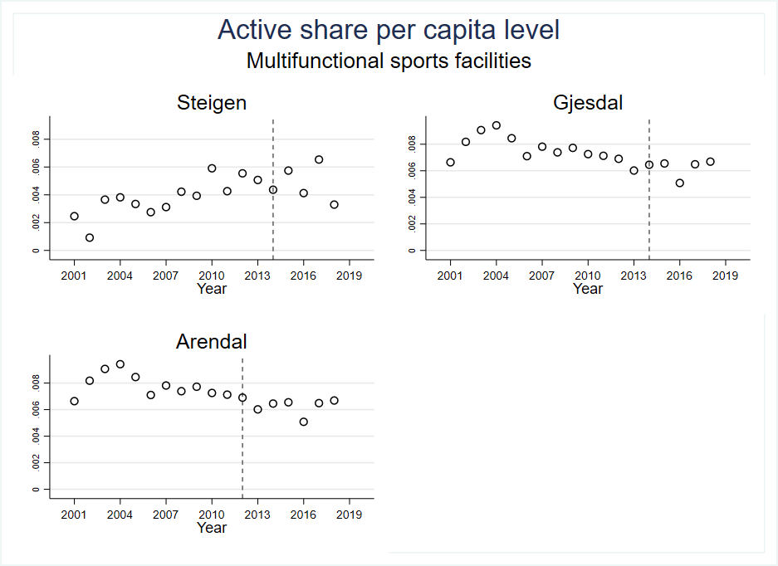

Figure 26 The three graphs show how the average active share per 1k capita has developed the last 18 years. A vertical indication line by 2014 indicates when the new multifunctional facility was built.

The development in small municipality may indicate that they who participate in sports, moves from one sport to another during the years. Figure 25 shows indications that some active members in material arts and athletics have moved to handball and volleyball from 2014, and some of those who did not like handball, started in athletics in 2017. The small municipality (Steigen) seems to have had a slight increase until 2013, and then the active share of the population decreases. As Figure 26 shows none of the municipalities have a notable change in the active share of the population. On the other hand, it might have been the increasing number of active sports members in the municipalities that has led to a demand for a new sports facility.

## Robustness

### South, North / Small, Medium, Large municipalities

There are significant differences in the Norwegian municipality regarding area size, number of inhabitants, economy and financial freedom of action. Every fifth year SSB publishes a report on the differences in the Norwegian municipalities. The latest report was published in April 2020 is based on municipality data from 2018. SSB groups the Norwegian municipalities after population size, economic workload and economic capacity. From these criteria, the municipalities divide into 27 various categories. The five main categories are the nine largest cities, municipalities with the highest tax income, small, medium, and large municipalities. Each of the main categories is divided into smaller subgroups, which categorize after, among other things, the municipality economy and number of inhabitants. (Kringlebotten, Langørgen, & Thorud, 2020)

By using the SSB split of the municipalities and split Norway in a southern and nothern part the dataset divides into five subsets with a smaller number of observations (n). By using these subsets to evaluate the robustness of the estimated coefficients from the main fixed-effects model in chapter “*The within estimator – fixed effect model”,* I will test the original models correctness.

In appendix figure 11 a split of Norway into north and south are visually illustrated. The subsets for the northern part represent 76.257 observations and the subsets for southern part represents 167.425 observations. By using SSB categories of different municipalities sizes, the smallest municipalities represent 120.805 observations, medium 87.172 observations and the larges municipalities are represented by 27.787 observations. With this subsets split of the data with assorted sizes, the estimated coefficients are compared with the original estimated fixed-effects model. The coefficients from the subsets are shown in Figure 27.

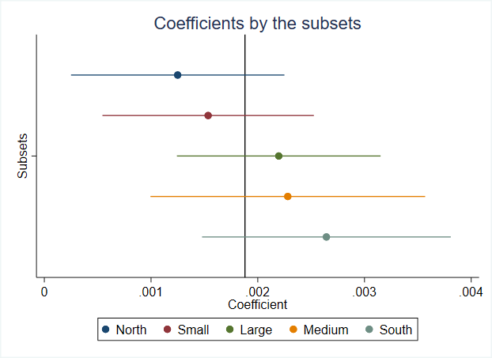

Figure 27 Shows the coefficients estimated for each subset of the data as described. The vertical line in the x-axis represent the coefficient from the original model in the analysis (0.00188***). In the y-axis the different subsets are represented.

76257 obs/ 117 clusters

120805 obs/ 183 clusters

27787 obs/ 42 clusters

87172 obs/ 132 clusters

167425 obs/ 252 clusters

The vertical line in Figure 27 illustrate the estimated coefficient from the original dataset from the fixed-effects model. Table 6 shows the estimated coefficient from the subsets compared to the original coefficient. The subset from the northern and southern part varies with 0,07 percentage points stronger and weaker than the original coefficient. The average between those two subsets equals the original coefficients. The subsets from the small and medium municipalities varies by 0,04 percentages points stronger and weaker than the original coefficient, and on average equals the original coefficient. The subset for the largest municipalities is the smallest subset and creates the coefficients nearest the original coefficient, with a deviation of 0,03 percentage points.

|  |  |  |  |  |
| --- | --- | --- | --- | --- |
| **Subsets** | **Coeff.** | **Original** | **Difference** | **Obs.** |
| South*** | 0,26 | 0,19 | 0,07 | 167425 |
| North* | 0,12 | 0,19 | -0,07 | 76257 |
| Small** | 0,15 | 0,19 | -0,04 | 120805 |
| Medium*** | 0,23 | 0,19 | 0,04 | 87172 |
| Large*** | 0,22 | 0,19 | 0,03 | 27787 |

*in percentage points*  * *p* < 0.05, ** *p* < 0.01, *** *p* < 0.001

Table 6 Estimated coefficients from the subsets. Compared to the original estimated coefficient from the fixed-effects model. All coefficients can be found in appendix table 14.

The created robustness check of the original data leads to an evaluation of how correct the original model performs and still leads to consistent estimates. (Athye & Imbens, 2017). As the estimated coefficients from the subsets shown in Figure 27 and the deviations in Table 6, the original model are rarely sensitive to the variation in the number of observations. There are some small variations between north and south and between small and medium municipalities. The estimated coefficients for the large municipalities created the coefficients which are nearest the original coefficient. When I calculate average of the five subset coefficients, the coefficients are 0,196, which is close to the original coefficient of 0,19, and then proves that model performs and lead to consistent estimates.

# Strengths and limitations

The master thesis investigates how the number of sports-specific facilities impacts the active share of the population in sports clubs. The results from the fixed-effects model and the underlying analysis indicate that the number of sports-specific facilities increases the population's active share.

However, the analysis is based on activity data and facility data divided into the respective municipalities. Most people participate in sports clubs in their home municipality, but in some cases, people join sports clubs outside their home municipality. The received data do not hold information if a person joins a sports club in their home municipality or a neighbourhood municipality. This will lead to some uncertainty about the members of the registered sports in each municipality. When creating the population’s active share in some cases e.g., small municipalities located around a larger city may have less activity inside the municipality because some “popular” sports are offered in another city nearby or a neighbour municipality. Such variations may appear when looking at data on the sports federation level.

The facility register contains all sport and culture facilities registered in Norway. Some of the facilities have no construction year registered. All the missing construction years are replaced by the year 1900, so the facility is counted for in the data. “Gode idrettsanlegg,” informs that data about Norway’s sports and culture facilities is not complete. The construction year is missing for 1845 facilities in the register. A share of these missing construction years most likely belongs in the period 2006 until 2018. In the same report from “Gode idrettsanlegg”, the author informs that construction year from 2015 until 2018 is not complete (Öhman, 2019). Since I have replaced all missing construction year with the year 1900, the facilities are counted for, but the increase in the number of facilities in the correct year cannot be correctly computed. Another challenge with the construction year, the facility is not fully available for all sports in the registered construction year in many cases. Some sports facilities may have a construction year in 2014 but are not fully available for sports before the second quarter of 2015. In other cases, the construction year is set later than when the first sports activity is offered. This means using the construction year to estimate the effect may be misleading.

Sports facilities are in many cases used for different sports, e.g., the multifunctional sports halls. Some sports require sports specific facilities like swimming and shooting, some sports do not use registered sports facilities but rent private rooms like storage rooms for their activity. Nevertheless, the main sports club activity uses registered sports facilities from the Ministry of Culture’s facility register. The analysis builds on the number of sports facilities per capita as the independent variable. To improve future analysis a more detailed facility register were all sports clubs us of sports facilities are registered. Such information would increase the possibilities to estimate more precise estimations for all sports in Norway, not just the sports with sport-specific facilities. Because of the trouble of linking all sports with a sports facility, the analysis considers the sports that have a link to a sport-specific facility, all other sports are exclude from the analysis.

In the chapter “New sport-specific facilities and development of the number of sports members” I have looked into how the number of sports members in different sports changes when a new sports specific facility is built. The four sports federations I have looked at are Climbing, Athletics, Gymnastics, and Martial arts. By randomly picking different seized municipalities, it has been possible to explain how new sports facilities influence different sports. I find that both climbing, and gymnastics have positive effects on new facilities. Neither Athletics nor martial arts do not show a clear increasing trend in the number of sports members in their sports.

In the chapter “

Multifunctional sports facilities” the activity in different municipalities is illustrated in Figure 23, Figure 24, and Figure 25. These municipalities built new facilities in 2014 or 2012, and in some sports, the actual registered sports members increased significantly, and other sports experienced a decrease. The smallest municipality of Steigen indicates that when new sports are offered in small municipalities, the activity switches from one sport to another (Olsen, 2014). In the municipality of Arendal, the graph in Figure 23 show that handball and gymnastics had a continuous increase in their activity since 2008, and particularly handball. So, the question is, are the new facility built based on a significant increase in the interest in handball and gymnastics, or has the new sports facility created more activity alone in this particular municipality. The municipalities of Gjesdal and Steigen have the same indications, affect the activity new sports facilities or the opposite? Using common sense, is it sports facilities that affect the activity, or is it the opposite that activity affects the need for more sports facilities? A increased interest in handball within a small municipality without an indoor facility the increased interest in handball would require an indoor facility. On the other hand, if a new multifunctional sports facility with special activity halls for athletics and gymnastics where the municipality has a large group of people who participates in athletics, do new sports members start with gymnastics because of the new facility? One example of this scenario is shown in the municipality of Steigen where there are athletics and martial arts with an increasing number of registered sports members before the new facility came. The new multifunctional sports hall includes halls for martial art but as well handball. The activity graph in Figure 25 shows that handball and volleyball were established in 2015, and at the same time, athletics and martial arts registered members decreases. These effects mentioned above, do the sports facilities affect the activity, or is it possible that activity can affect new sports facilities. These questions can be explained as reversed causality, which means that X affects Y, but Y may also affect X. In theory, reversed causality explains that activity and facilities are associated and that activity causes a demand for new sports facilities builds. (Glen, 2020).

The analysis is built on panel data, but even with these types of data and models like fixed-effects, it is far from trivial to identify the causal effect of an increased number of facilities on the population’s active share, if reverse causality is present. There are possibilities to improve the models by including lags on the active share, but the timing of the facility's effect may be difficult to pinpoint. The construction year is not a 100% indicator for when the facility available to use.

“Fixed effects regression models for panel data are often used to adjust for selection on unobservable, and several types of researches literature on the topic have relied heavily on findings from these models” (Sobrel, 2012). The fixed-effects regression model used in the analysis considers both observed and unobserved variables that do not vary over time. If the data has time-varying unobserved variables, it will limit the estimations (Hill, Davis, Roos, & French, 2020). The fixed-effects model captures all time-invariant unobserved heterogeneities by the unit-specific error term , but the model core assumes strict exogeneity. “The key point is that this assumption is necessarily violated in case of reverse causality” (Leszczensky & Wolbring, 2019). A strict exogeneity forbids current values of to correlate within past, present, and future values of . If the active share () affects , that is, if reverse causality is present, is necessarily correlated with . When one of the core assumptions for the fixed-effects model violates of reverse causality causes bias to the estimates. (Leszczensky & Wolbring, 2019). To avoid the problem with revered causality there is a possibility of lagging the independent variable (number of sports facilities per capita), which eliminates the strong and untestable strict exogeneity assumption. However, it introduces the similarly strong and unstable assumption that unobserved variables are serially uncorrelated. Earlier research shows that by lagging the independent variable in a fixed-effects model rarely solves the endogeneity problem posed by unobserved variables.

The performed robustness check illustrates that the fixed-effects model estimates robust estimations. It could be interesting to include covariates like the statistical values SSB uses to decide if a municipality is small, medium, and large in future investigations. These covariates may affect the independent variable. More wealthy municipalities may have the freedom to facilitate more common and sport-specific facilities. An even more extended analysis would be to include longitude and latitude data for all sports members and all sports facilities to combine how the number of sports facilities and the distance from home to your facility affect sports participation.

Another limitation of the data is that sports clubs in Norway just represent the activity. An even more complete analysis, an idea would be to include activity data for all privet gyms in Norway.

# Conclusion

The master thesis aims to investigate the causal effect on the active share of the population when the number of sports facilities increases. Do sports facilities increase activity in sports clubs?

I was using data from *NIF* for sports memberships and all sports facilities listed in the sports facility register from the Ministry of culture. The population data from NSD creates a large panel dataset used in this thesis. The complete dataset has a large variety of observations across 18 years, 369 municipalities, and activity registered in 52 different sports federations across all the municipalities these 18 years. The highly variated data tested with a fixed-effects model with clusters around the municipalities are used to estimate the effect the number of sports facilities per capita impacts on the activity share of the population, in the sports clubs in Norway through their respective sports federations. Because of the significant differences in sports federations sizes, some of the smallest federations with activity less than 5000 members are collected in a group named “other” federations.

In the model evaluation, the number of sports facilities per capita is used as the independent variable as a baseline model. Trough the model evaluation, a final model for the analysis are chosen where the independent variable “the number of sports-specific facilities per capita” is used. The fixed-effect model with the standardized number of sports-specific facilities per capita as the independent variable used to estimate the coefficient for each sports federation separately. The estimated coefficient is created for those sports federations with a sports-specific facility linked to the federation. The estimates show that nearly all federations’ active share of the population positively affects by the number of facilities per capita. From a statistical point of view, five sports federations gave a significant estimate with p-values less than 0.05, which is Golf, Gymnastics, Climbing, Sailing, and skates. Gymnastics and handball are the two sports federations of the top six sports federations with the highest increase in the number of active sports members in the last years, as shown in Figure 8. Since handball does not use sports-specific facilities, there are no estimations for this federation. The data show an increased number of gymnastic halls, in actual numbers around 60 gymnastic halls and more than 100.000 sports members. The increasing trend in actual numbers of members impacts the estimations significantly. Climbing has as well statistically significant estimates, the actual number of facilities are significantly higher per climbing member in the federation with more than 200 facilities in 2018.

With the estimation for all sports federations with a linked sports-specific facility I can say that the number of sports facilities per inhabitant impacts the active share of the population participates in sports through sports clubs. The model estimates show that the population's active share increases when the number of sports-specific facilities increases. In some sports, the effects are higher than in others. However, is this a result of earlier political decisions that some facility types have had a higher priority than others. From 1948 to 2015, the sports facilities that have been prioritized are swimming pools, skiing arenas, and multifunctional sports halls. The sports facilities with a large investment volume from 1949 to 2010 are football courts and multifunctional sports halls (Breivik & Rafoss, 2017). By nature, I will think that priorities from the second world war and up until today's new sports facilities, the demand from some sports have been an essential factor in which type of sports facilities constructed. There have been built many football courts because there is significantly higher interest in football than martial arts e.g.

The analyzed sports federations and which built a new sports-specific facility and the municipalities who had built a multifunctional sports hall found that some sports like handball in Arendal, martial arts in Steigen, and gymnastics in Oslo had an increasing interest in their sport before the facility came. In the analysis where I have been looking into the effects of some of the different sports federations and how multifunctional sports facilities in the municipalities who were randomly picked indicates that some facilities may have been built because of an increased interest in some sports like handball in Arendal, martial arts in Steigen, and gymnastics in Oslo. These municipalities had an increasing number of active sports members before a new facility was built. Unfortunately, the activity decreases e.g., in Steigen for martial arts after the facility came through, but in Oslo, Gymnastics continued to increase.

Nevertheless, as possibility in earlier research, sports have been more diverse after new sports are introduced in Norway. In the report from Rafos & Troelsen, they inform that there is a lack of sports facilities for diversity in Norway's sports activities, and many of the sports facilities are outdated (Rafos & Troelsen, 2010) (NIF Norges Idrettsforbund, 2019). The active share of the investigated municipalities' population does not change significantly after the new multifunctional hall is built as shown in Figure 26. On the other hand, by looking into different sports federations and their changes in the number of sport members after a new facility came, some sports increase significantly, and others have smaller changes or do not change. The results from the multifunctional halls analysis and the different sports federations show that there are for the most positive effects when new facilities are built. However, the changes differ between municipality sizes and sports interests.

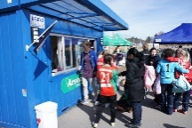Nevertheless, the possibility to offer sports activities in sports facilities in Norwegian society depends on voluntary work. On the football court, you need coach or football referee, in the food stand, or in the administrations to organize football matches, pay the bills, the list is long. The people behind the activity are a crucial factor. A news article from 2013 states that the focus on sports funding from the government is essential for the sports clubs, but can the funding cover for all the approximately 700 000 volunteers who make it possible to offer a sports activity (Tøien, 2013).

How a person chooses their sports activity depends on many factors, some likes the team play in, e.g. football and handball, and others prefer sports of more individual nature. In recent decades, many new sports have come to Norway, and the supply of different sports types has increased. With a higher supply of different sport, the demand for different sports specific facilities will increase.

The final conclusion of this master thesis must be that sports facilities are an essential factor in making it possible to offer sports for everyone. The effects of new facilities, on the other hand, depend on the sport and the municipality's size.

# References

Athye, S., & Imbens, G. W. (2017). *The state of Applied Economitrics: Causality and Policy evaluation.* Journal of Economic Perspectives.

Beirmann, M. (2011). *Claims and effects of sport-in-development prjects - A state-of-the-art analysis.*

Bolstad, E. (2020). *Erik Bolstad*. Retrieved from https://www.erikbolstad.no/geo/

Breivik, G., & Rafoss, K. (2017). *Fysisk aktivitet; omfang, tilrettelegging og sosial ulikhet.*

Bring. (2020). *Bring.no*. Retrieved from Used the file: Nye endrede og opphørte postnummer: https://www.bring.no/radgivning/sende-noe/adressetjenester/postnummer/mer-om-postnummer/kommuneendringer

Dagsavisen. (2019). Denne idretten øker mest i Norge.

Fiva, J. H., Halse, A. H., & Natvik, G. J. (2020). *Local Governement Dataset.* Oslo.

Flekkøy, K. G. (2020). *Aktive barn blir spreke gamlinger*. Retrieved from forsking.no: https://forskning.no/barn-og-ungdom-mat-og-helse-norges-idrettshogskole/aktive-barn-blir-spreke-gamlinger/1639988

Gang, C., Taylor, P. A., Haller, S. P., Kircanski, K., Stoddard, J., Pine, D. S., . . . Cox, R. W. (2018). *Human Brain Mapping.*

Glen, S. (2020). *Reverse Causality: Definition, Examples*. Retrieved from StatisticsHwoTo.com: https://www.statisticshowto.com/reverse-causality/

Gode idrettsanlegg. (2020). *Godeidrettsanlagg*. Retrieved from https://www.godeidrettsanlegg.no/forbildeanlegg/sparebanken-sor-amfi-turnanlegg

Gofsiden. (n.d.). *golfsiden.com*. Retrieved from Gofsiden: https://www.golfsiden.com/ngfstatistikk100604.html

Golfforbund, N. (2008). *golfhistorie.no*. Retrieved from Golfhistorie: https://www.golfhistorie.no/begivenheter/2010/medlemstallet-synker.-hva-skjer?from=meny

Graven, A. R. (2012). Fete barn sliter ved mye skermtid. pp. https://forskning.no/internett-barn-og-ungdom-mat/fete-barn-sliter-ved-mye-skjermtid/686191.

Gunasekara, F. I., Richardson, K., Carter, K., & Blakely, T. (2013). *Fixed effects analysis of repeated measures data.* International Journal of Epidemiology.

Hill, T., Davis, A. P., Roos, J. M., & French, M. (2020). *Limitations of fixed-effects models for panel data.* ResearchGate.

Huan, X. (2007). *The Evolution of Urban Society and Social Changes in Sports Participation at the Grassroots in China.* International Review for the Sociology of Sport.

Ikenwilo, D. (2013). *A difference-in-differences analysis of the effect of free dental check-ups in.*

Jank, W. (2011). *Business Analytics for Manageres.* Springer.

Jonsson, G., Skoglund, W., & Bye, R. (2012). *Idrottsanläggningars betydelse – bortom idrotten!*

Kringlebotten, M., Langørgen, A., & Thorud, A. B. (2020). *Gruppering av kommuner etter folkemengde og økonomiske rammebetingelser 2018.* Statistisk sentralbyrå / statistics Norway.

Leszczensky, L., & Wolbring, T. (2019). *How to Deal with Reverse causality using panel data? Recommendations for researchers based on a simulation study.* Saga journals.

Limstrand, T. (2008). *Environmental characteristics relevant to young people's use of sports facilities: a review.* Scandinavian Journal of Medicine & Science in sports.

Limstrand, T., & Rehrer, N. J. (2008). *Young people’s use of sports facilities: A Norwegian study on physical activity.* Scandinavian Journal of Public Helth.

Morgan, S. L. (2013). *Handbook of causal analysis for social research.* Springer.

Museumofplay. (2020). *Museumofplay*. Retrieved from Video Game History Timeline: https://www.museumofplay.org/about/icheg/video-game-history/timeline?fbclid=IwAR2v08y7Pk-isPL3354xB4fLgyZ5QUwOUu0taRONMfzV6Lo2VFV-JCUDw8Q

Mutl, J., & Pfaffermayr, M. (2010). *The Hausman test in a Cliff and Ord panel model.* The Econometircs journal.

Mårdalen, I. (2019). *forskining.no*. Retrieved from Norske 9-åringer beveger seg enda mindre enn før: https://forskning.no/barn-og-ungdom-skole-og-utdanning/ny-studie-norske-9-aringer-beveger-seg-enda-mindre-enn-for/1299308

NGTF, N. (2019, June 17). *gymogturn.no*. Retrieved from Kulturdepartementet og NGTF i nyttig statusmøte: https://www.gymogturn.no/2019/06/17/kulturdepartementet-og-ngtf-i-nyttig-statusmote/

NIF Norges Idrettsforbund. (2019). Idretten Vil! Langtidsplan for Norsk Idrett 2019-2023. Retrieved from Idretten Vil! Langtidsplan for Norsk Idrett 2019-2023: https://www.idrettsforbundet.no/contentassets/8149372c5d4d439cb1b34fc1625032f0/idretten-vil_langtidsplan-for-norsk-idrett-2019-2023_lr.pdf

NIF, Norges idrettsforbund. (2020, june 29). Mail from Terje Kleven Norges idrettsforbund. *Personal communication*.

NIF's Anleggsrapporten. (2018). *NIF*. (K. Norges idrettsforbund, Producer) Retrieved from https://www.idrettsforbundet.no/tema/anlegg/: https://www.idrettsforbundet.no/tema/anlegg/

Norges Idrettsforbund. (2019). *Idretten skal!* 2019: Norges idrettsforbund.

Norges Klatreforbund. (2020). *klatring*. Retrieved from https://klatring.no/var-historie

Olsen, Ø. A. (2014). *De første har allerede tatt allhuset i Steigen i bruk*. Retrieved from an.no: https://www.an.no/nyheter/de-forste-har-allerede-tatt-allhuset-i-steigen-i-bruk/s/1-33-7528192

Perinetti, G. (n.d.). *Sta Tips Part IV: selsction, interperation and reporting of the interclass correlation coefficient.* Soth Eur J Orthod Dentofec Res.

Prins, R. G., Empelen, P. v., Velde, S. J., Timperio, A., Lenthe, F. J., Tak, N. I., . . . Oenema, A. (2019). *Availability of sports facilities as moderator of the intention–sports participation relationship among adolescents.* Health Education Research.

Rafos, K., & Troelsen, J. (2010). *Sports facilities for all? The financing, distribution and use of sports facilities.* ResearchGate.

Rajendran, P. (2019, march 28). *towards data science.* Retrieved from https://towardsdatascience.com/causal-inference-using-difference-in-differences-causal-impact-and-synthetic-control-f8639c408268

Reimers, A. K., Wagner, M., Alvadides, S., Steinmayr, A., Reiner, M., Schmidt, S., & Woll, A. (2014). *Proximity to Sports Facilities and Sports Participation for Adolescents in Germany.* University of Sao Paulo, Brazil.

Reithaug, I. B. (2017). *en kvantitativ studie av sammenhengen mellom Oslo-ungdomens bosted og deltakelse i organisert idrett.* Univiersitetet i Oslo.

Røhne, B., & Abrahamsen, M. H. (2018). *Det store norske leksikon*. Retrieved from nettbrett: https://snl.no/nettbrett?fbclid=IwAR1hReg_xHfLUbCWzq-tAqaxeVKpshVrt9xKQDNIOn-9N9Lq7SCPDMnzgUc

S. A. (2015). *Stavanger aftenblad*. Retrieved from Dirdal har fått ny storstue: https://www.aftenbladet.no/lokalt/i/bL3pd/dirdal-har-fatt-ny-storstue

Sobrel, M. E. (2012). *Does Marriage Boost Men's Wages?: Identification of Treatment Effects in Fixed EffectsRegression Models for Panel Data.* Journal of the American Statistical Association.

SSB. (2018). *Kulturstatistikk 2018 SSB.*

Steinmayer, A., Felfe, C., & Lechner, M. (2011). *The closer the sportier? Children's sports activity and their distance to sports faclities.* European Group for Research into Elderly and Physical Activity (EGREPA).

Store Norske leksikon . (2020). *Store Norske leksikon* . Retrieved from Norges gymnastikk og turnforbund: https://snl.no/Norges_Gymnastikk-_og_Turnforbund

The Ministry of Culture. (2019). *Bestemmelser om tilskudd til anlegg for idrett og fysisk aktivitet.* Oslo: kulturdepartement, Det Kongelige. Retrieved from https://www.regjeringen.no/contentassets/3b11076ff1204acca5d9c9d680e57ab8/v-0732-b_2019_bestemmelser-om-tilskudd-til-anlegg-for-idrett-og-fysisk-aktivitet-2019-v2-nov2019.pdf

TNS Opinion & Social at the request of. (2010). *Sport and Physical Activity.*

Tøien, P. (2013). Norsk idrett avhengig av frivillighet. *Aftenposten*. Retrieved from https://www.aftenposten.no/meninger/debatt/i/y36bR/norsk-idrett-avhengig-av-frivillighet

Wicker, P., Hallmann, K., & Breuer, C. (2011). *Analyzing the impact of sport infrastructure on sport participation using.* Elsevier.

Öhman, C. (2019). *Statistikk over antall idrettsanlegg bygget i perioden 2006-2018.* NTNU, Senter for idrettsanlegg o teknologi.

1. The official age groups from NIF are as follows: 0-5 years, 6-12 years, 13-19 years, 20-25 years and 26 and older.
2. The report *“statistikk over antall idrettsanlegg bygget i perioden 2006-2018”* informs that there are 1845 facilities without a construction year. These are manually sett til construction year 1900. This will count the facilities, but not affect an increase in the number of facilities in the periode from 2001 to 2018. (Öhman, 2019)
3. The facility register from 2019, as the latest updated registers, contains information of two diffecent municiplalities who were merged in 2018. This applies the municipalities Færder og Indre Fosen. These two municiplaities are manuely divieded into their old municipalities by using their addresses, look up web sites to find their zip codes. The zip codes are used to define their “old” municipalitye by using the web site Bolstad that offers information of all zip codes that has existed in Norway. (Bolstad, 2020)
4. archery facility, football fields, athletics facilities, golf course, equestrian facilities, dog sport facilities, sports halls, skating rinks, climbing plant, air sports facilities, smaller outdoor facilities, motorsports facilities, racket sports facilities, Samiske sports facilities, skate facilities, Skiing and alpine facilities, shooting facilities, swimming and diving facilities, cycling facilities, water sports facilities.
5. The Sports federations with less than 5000 sports members in 2018 are: Norges Hundekjørerforbund, Norges Judoforbund, Norges Roforbund, Norges Cricketforbund, Norges Kickboxing Forbund, Norges Vektløfterforbund, Brettforbundet, Norges Bowlingforbund, Norges Curlingforbund, Norges Biljardforbund, Norges Castingforbund, Norges Vannski- og Wakeboard Forbund, Norges Fekteforbund, Norges Rugbyforbund, Norges Ake-, Bob-, Og Skeletonforbund, Norges Softball og Baseball Forbund.
6. In the article from SSB regarding how Norwegian municipalities grouped. Bykle is the municipality with the highest corrected income per capita.
7. Complete graphs of how the actual numbers of sports facilities for Golf and Gymnastics are presented in appendix figure 11.