Appendix 1 The developemnt of activ memberships in sports clubs the last 18 years.
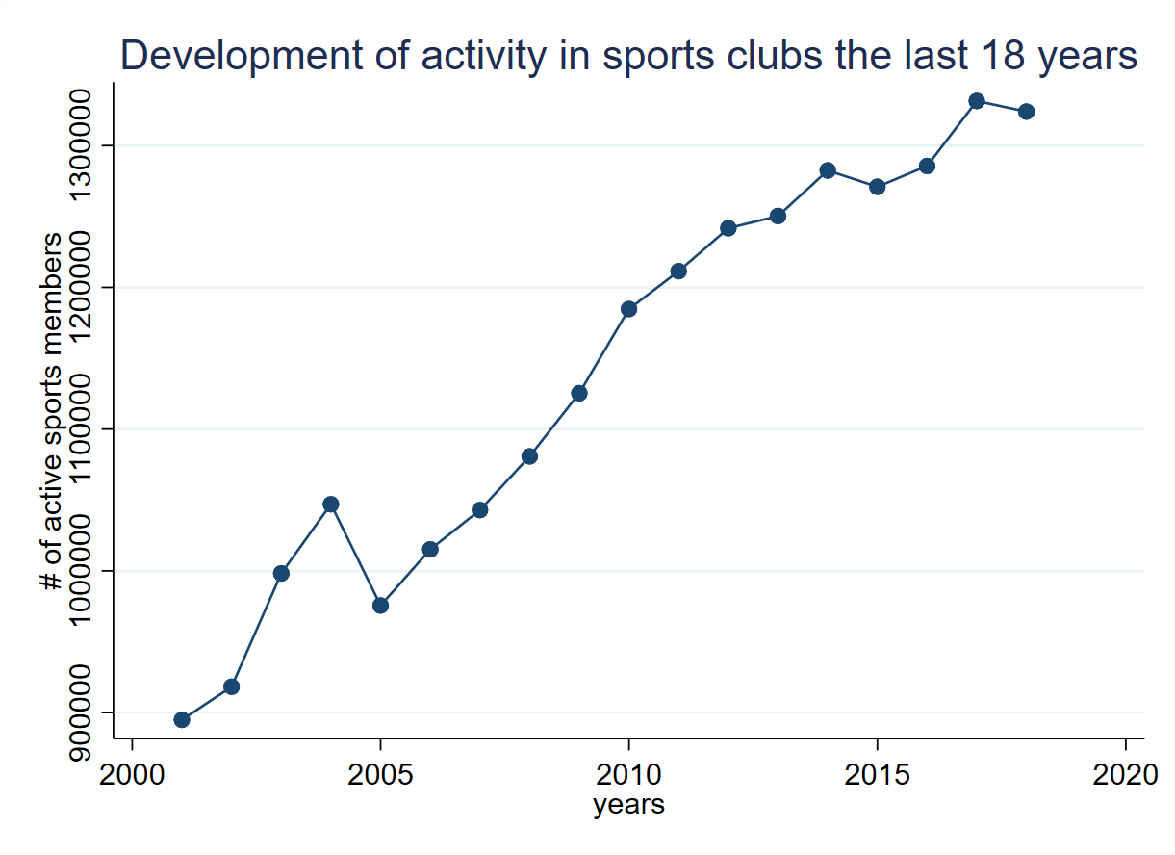

Appendix 2 The developemnt of actual active share in sport clubs of the population
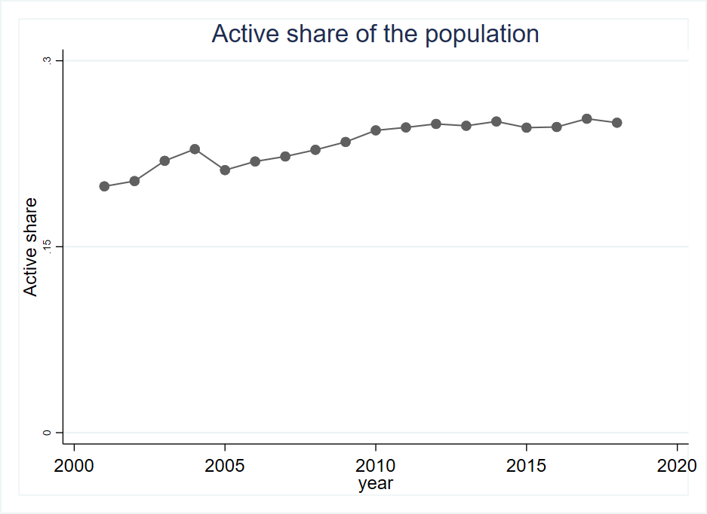

Appendix 3 Actual number of sports facilities per inhabitant in Norway form 2001 until 2018

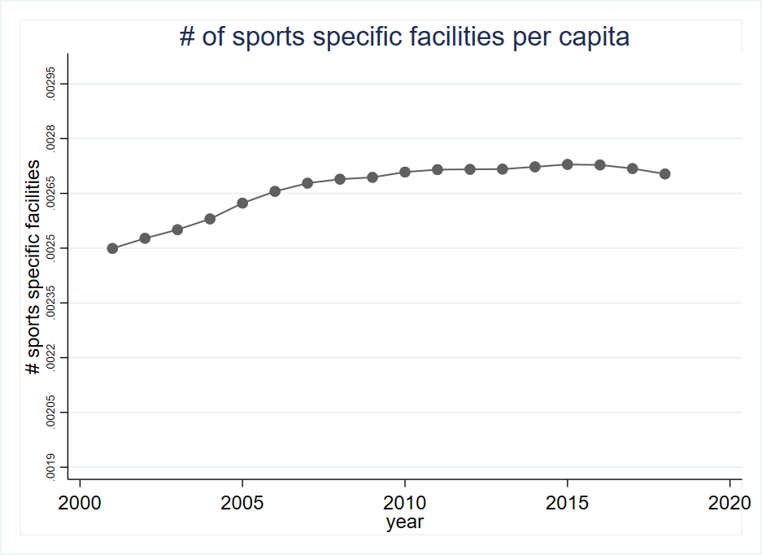

Appendix 4 Desription of how the coplete dataset are created.

Building the panel data

With the provided data, a complete dataset with information on population, active sports members, and the number of sports facilities is built. A full description of how the dataset is built is found in the following chapters.

NIF activity data matched with municipality numbers
The provided data from NIF was not specified with the "old" municipality numbers, because of the municipality change in January 2020. In that case, the dataset was constructed by combining several data sources. First of all, the address dataset of all sports clubs in Norway with the given zip code (NIF) matched with the zip codes with data from Bring (Bring, 2020). The zip code data from Bring contains zip codes and their related municipality number before and after the municipality merge in 2020. The file from Bring is not a complete overview of all new and old zip codes for the current period from 2001 to 2018. In addition, a have used information from Erik Bolstad's (Bolstad, u.d.) web site that gives a nearly complete overview of all new and old zip codes in Norway and their respective municipality numbers. The sports club address file from NIF is matched with the zip code list from Bring and leads to a complete sports club address overview where it is possible to identify with the municipality the sports clubs belong too.

The complete address list of all sports clubs with municipality numbers is matched with the dataset from NIF with all active members per sports club. The merge gives a new dataset of all municipalities where all active sports members are divided into their respective sports federations, sports club, and age groups. This file contains of the following variables: year, municipality, Sports Federation, Sports club, age group, and activity. The purpose of this report is to look at the differences of all sports federations across all municipalities. In that case, I do not need all the information divided per sports club. The dataset is collapsed per municipality and sports federation. The collapsed dataset contains the variables: year, municipality, Sports Federation, activity for the different age groups.

Merging sports facility data
To extend the dataset with data about sports facilities, the facility data from the Norwegian culture Ministry (Ministry Culture, u.d.), were analyzed. The dataset contains data from all cultural and sports facilities, form sanitary facilities and offices to the major national sports facilities. Since I lock into the area on how the number of sports facilities affects organized sports activity, several facilities have to be removed from the original dataset. Appendix XX provides a total overview of all the facilities removed from the original facility dataset. The facility data contains information on which municipality they belong, by the municipality name. The facility dataset has no information on the municipality number; the data are matched with an extracted file from the dataset "Local Government Dataset" (Fiva, Askill, & Natvik, 2017) with the features municipality name and number.

The facility dataset contains multiple variables, and the most important once are facility class (four different classes), facility category, facility type, and year of construction. Some sports facilities are special facilities to be used in one specific sport and others are shared facilities that many different sports have the possibility to use. In my analysis, I want to see if there are some differences across the municipalities for the different sports federations. In that case, I have used the facility category and facility type to identify which facility belongs to which sports federations. Appendix table 6 gives an overview of which sports facilities are connected to each sports federation. Since not every facility it possible to connect to a specific sports federation, and some facilities can be used for many different sports, the facility data are categorized as common facilities and federation specific facilities. Both categories are summed up to the total number of sports facilities available for all sports activities. The facilities are counted after the construction year. The facilities are spread across all the municipalities for the current analyzing period from 2001 to 2018.

The complete dataset
The two datasets described above are merged into one dataset with the municipality number as the link between two datasets. Further are population data from NSD for each municipality and age group merged into the dataset, and in the end, are data from the Local Government Dataset merge as a control for the total population in each municipality is correct. In addition, the population control from the Local Government Dataset I have used features for balancing the data and the variable unemployment in addition to the total population.

The final dataset contains the following features: year, municipality number, sports federation, active for the different age groups, the population for each age group and the total population, total number of sports facilities, the total number of federation specific sports facilities. All activity, facility, and population data are distributed across all municipalities and years.

Appendix 4B Desription of how the coplete dataset are created

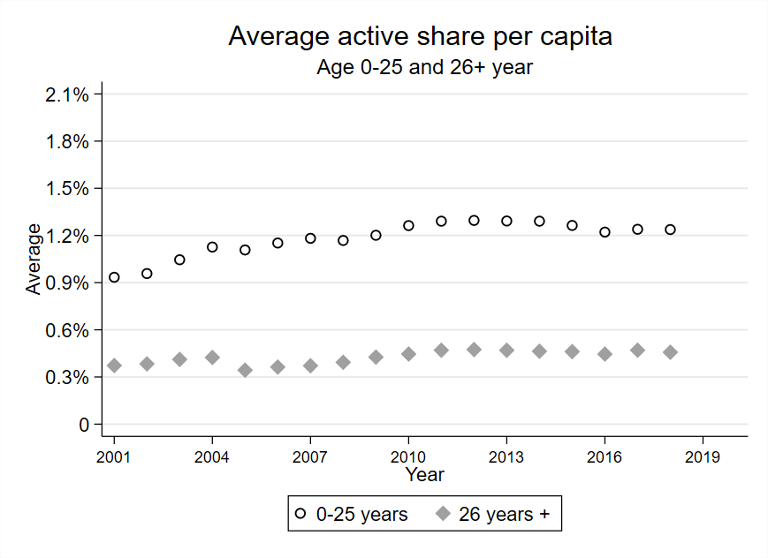
Figure shows the average active share of the population across all municipalities and federations by the age group 0-25 and for those 26 years and older. The y-axis shows the average active share of the population across all municipalities and federations, and the years is shown in the x-axis.

Appendix 5 Removed facility categores form the facility register from the ministyr of culture.
Category 1 | Category 2
Anleggsklasse | Nærmiljøanlegg
Anleggskategori | Friluftslivsanlegg
Anleggstype | Badeplass
Anleggstype | Bibliotek
Anleggstype | Båthus
Anleggstype | Dagsturhytte
Anleggstype | Flerbrukslokale for kultur
Anleggstype | Flerbruksområde (Ute)
Anleggstype | Friluftsområde
Anleggstype | Friplassen
Anleggstype | Galleri
Anleggstype | Gapahuk
Anleggstype | Garderobebygg
Anleggstype | Kino Klubbhus
Anleggstype | Lager- og garasjebygg
Anleggstype | Museum
Anleggstype | Nærmiljøkart
Anleggstype | Orienteringskart
Anleggstype | overnattingshytte
Anleggstype | Parkouranlegg
Anleggstype | Produksjons og øvel lokaler
Anleggstype | Reionlat kulturanlegg
Anleggstype | Sanitærbygg
Anleggstype | Svenekunst lokale
Anleggstype | Sikkringshytte
Anleggstype | Skatepark
Anleggstype | Turkart
Anleggstype | Tursti
Anleggstype | Turvei
Anleggstype | Utendørs kulturarena

Appendix 6 Complete list of how sports facilities matched with their sports federations.
Facility type / Facility category | Sports federations
Agilityhall / Hundesportanlegg | Norges Hundekjørerforbund
Akebakke / Ski- og alpinanlegg | Norges Skiforbund
Alpinbakke / Ski- og alpinanlegg | Norges Skiforbund
Anlegg for radiostyrt motorsport / Motorsportanlegg | Norges Motorsportforbund
Baneracing/roadracingbane / Motorsportanlegg | Norges Motorsportforbund
Baseballpitch / Mindre utendørsanlegg | Norges Softball og Baseball Forbund
Bilcross/rallycrossbane / Motorsportanlegg | Norges Motorsportforbund
BMX-anlegg / Sykkelanlegg | Norges Cykleforbund
Bordtennisbord (ute) / Racketsportsanlegg | Norges Bordtennisforbund
Bordtennishall / Racketsportsanlegg | Norges Bordtennisforbund
Bowlinghall / Idrettshaller og aktivitetssaler | Norges Bowlingforbund
Bueskytterbane (ute) / Bueskytteranlegg | Norges Bueskytterforbund
Bueskytterhall / Bueskytteranlegg | Norges Bueskytterforbund
Castinganlegg / Vannsportanlegg | Norges Castingforbund
Cricketpitch / Mindre utendørsanlegg | Norges Cricketforbund
Curlinghall / Is- og skøyteanlegg | Norges Curlingforbund
Danse-/cheerleadingssal / Idrettshaller og aktivitetssaler | Norges Danseforbund
Diskgolfanlegg / Mindre utendørsanlegg | Norges Golfforbund
Driving range / Golfanlegg | Norges Golfforbund
Feltskytebane (ute) / Skyteanlegg | Norges Skytterforbund
Fotball treningsfelt / Fotballanlegg | Norges Fotballforbund
Fotballbane gress / Fotballanlegg | Norges Fotballforbund
Fotballbane grus / Fotballanlegg | Norges Fotballforbund
Fotballbane kunstgress / Fotballanlegg | Norges Fotballforbund
Fotballhall / Fotballanlegg | Norges Fotballforbund
Freestyle- og snowboardanlegg / Ski- og alpinanlegg | Norges Skiforbund
Friidrett treningsanlegg (inne) / Friidrettsanlegg | Norges Friidrettsforbund
Friidrett treningsanlegg (ute) / Friidrettsanlegg | Norges Friidrettsforbund
Friidrettshall / Friidrettsanlegg | Norges Friidrettsforbund
Friidrettsstadion grus / Friidrettsanlegg | Norges Friidrettsforbund
Friidrettsstadion kunststoff / Friidrettsanlegg | Norges Friidrettsforbund
Galoppbane / Hestesportanlegg | Norges Rytterforbund
Gokartbane / Motorsportanlegg | Norges Motorsportforbund
Golfbane / Golfanlegg | Norges Golfforbund
Hoppbakke / Ski- og alpinanlegg | Norges Skiforbund
Hundekjøringsanlegg / Hundesportanlegg | Norges Hundekjørerforbund
Hurtigløpsbane (ute) / Is- og skøyteanlegg | Norges Skøyteforbund
Hurtigløpshall / Is- og skøyteanlegg | Norges Skøyteforbund
Ishockeybane (ute) / Is- og skøyteanlegg | Norges Ishockeyforbund
Kampidrettsanlegg / Idrettshaller og aktivitetssaler | Norges Kampsportforbund
Klatre/buldrevegg (inne) / Klatreanlegg | Norges Klatreforbund
Klatre/buldrevegg (ute) / Klatreanlegg | Norges Klatreforbund
Klatrehall / Klatreanlegg | Norges Klatreforbund
Korthullsbane / Golfanlegg | Norges Golfforbund
Langrennsanlegg / Ski- og alpinanlegg | Norges Skiforbund
Lerduebane (ute) / Skyteanlegg | Norges Skytterforbund
Minigolfbane / Golfanlegg | Norges Golfforbund
Modellflyanlegg / Luftsportanlegg | Norges Luftsportforbund
Motocrossbane / Motorsportanlegg | Norges Motorsportforbund
Motorbåtanlegg / Vannsportanlegg | Norges Motorsportforbund
Opplæringsbasseng (inne) / Svømme- og stupeanlegg | Norges Svømmeforbund
Opplæringsbasseng (ute) / Svømme- og stupeanlegg | Norges Svømmeforbund
Padeltennisbane / Racketsportsanlegg | Norges Tennisforbund
Parkouranlegg / Mindre utendørsanlegg | Norges Gymnastikk- og Turnforbund
Petanquebane / Mindre utendørsanlegg | Norges Friidrettsforbund
Pistolbane (ute) / Skyteanlegg | Norges Skytterforbund
Ridebane / Hestesportanlegg | Norges Rytterforbund
Ridehall / Hestesportanlegg | Norges Rytterforbund
Ridesti / Hestesportanlegg | Norges Rytterforbund
Riflebane (ute) / Skyteanlegg | Norges Skytterforbund
Ro-/padleanlegg / Vannsportanlegg | Norges Roforbund
Rulleskøytebane / Is- og skøyteanlegg | Norges Skøyteforbund
Sandhåndballbane / Mindre utendørsanlegg | Norges Håndballforbund
Sandvolleyballbane / Mindre utendørsanlegg | Norges Volleyballforbund
Sanitærbygg / Idrettshus og servicebygg | Skal ikke med
Seilanlegg / Vannsportanlegg | Norges Seilforbund
Skatehall / Skateanlegg | Brettforbundet
Skatepark / Skateanlegg | Brettforbundet
Skileikanlegg / Ski- og alpinanlegg | Norges Skiforbund
Skiskytteranlegg / Ski- og alpinanlegg | Norges Skiskytterforbund
Snøscooterbane / Motorsportanlegg | Norges Motorsportforbund
Speedway/longtrackbane / Motorsportanlegg | Norges Motorsportforbund
Squashanlegg / Racketsportsanlegg | Norges Squashforbund
Stall / Hestesportanlegg | Norges Rytterforbund
Stupebasseng (inne) / Svømme- og stupeanlegg | Norges Svømmeforbund
Stupebasseng (ute) / Svømme- og stupeanlegg | Norges Svømmeforbund
Tennisbane (ute) / Racketsportsanlegg | Norges Tennisforbund
Tennishall / Racketsportsanlegg | Norges Tennisforbund
Terrengsykkelløype / Sykkelanlegg | Norges Cykleforbund
Travbane / Hestesportanlegg | Norges Rytterforbund
Trenings-/konkurransebasseng (inne) / Svømme- og stupeanlegg | Norges Svømmeforbund
Trenings-/konkurransebasseng (ute) / Svømme- og stupeanlegg | Norges Svømmeforbund
Trial/enduroløype / Motorsportanlegg | Norges Motorsportforbund
Turnhall / Idrettshaller og aktivitetssaler | Norges Gymnastikk- og Turnforbund
UDEFINERT / Ski- og alpinanlegg | Norges Skiforbund
UDEFINERT / Svømme- og stupeanlegg | Norges Svømmeforbund
UDEFINERT / Sykkelanlegg | Norges Cykleforbund
UDEFINERT / Vannsportanlegg | Norges Motorsportforbund
Vannskianlegg / Vannsportanlegg | Norges Vannski- og Wakeboard Forbund
Velodrom (ute) / Sykkelanlegg | Norges Cykleforbund
Avgangs- og landingsanlegg / Luftsportanlegg | Norges Luftsportforbund
Biljardhall / Idrettshaller og aktivitetssaler | Norges Biljardforbund

Appendix 7 Scatter plot of all observations og the indipandent and the dependent variable.
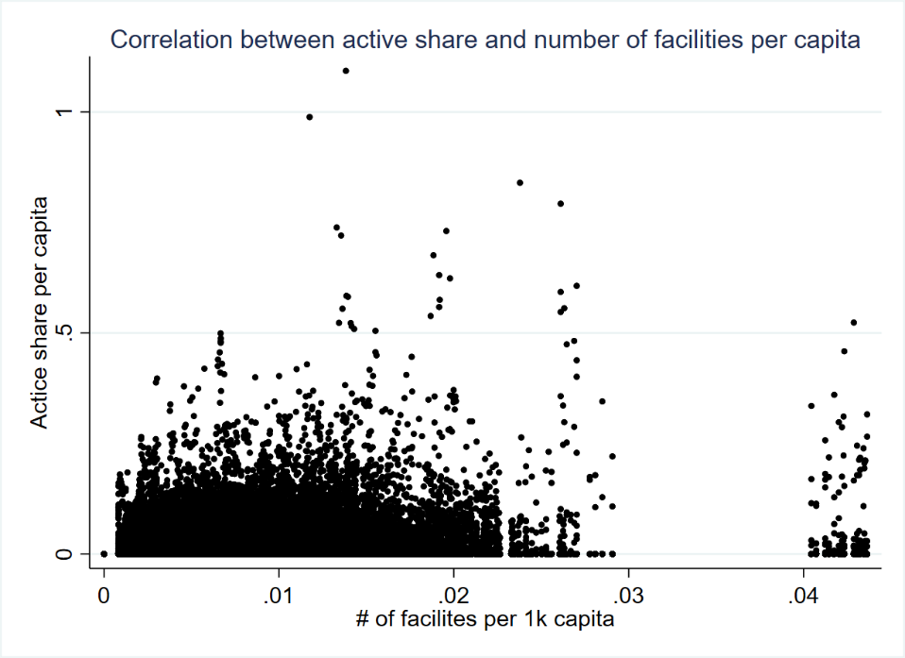
The small cluster to right in the graph is the municipality Bykle. The cluster may indicate that there is some mismatch when the sports facilities are linked to the municipality number. The municipality are in the final model removed from the dataset

Appendix 8 Statistical mean and standard error for the dependent variable and the independent variable sports specific facilites per capita level and sports common facilities per capita level.
Summary statistics: mean sd N by(SFnewcat )
Sfnew: Norges Amerikanske Idretters Forbund
 | mean | sd | N
activesharetot | 0 | .002 | 6586
SFfac prtotCapita | 0 | 0 | 6586
ComfacuniqePerCapita | .001 | .001 | 6586
Norges Badmintonforbund
activesharetot | .001 | .004 | 6586
SFfac prtotCapita | 0 | 0 | 6586
ComfacuniqePerCapita | .001 | .001 | 6586
Norges Bandyforbund
activesharetot | .002 | .006 | 6586
SFfac prtotCapita | 0 | 0 | 6586
ComfacuniqePerCapita | .001 | .001 | 6586
Norges Basketballforbund
activesharetot | 0 | .001 | 6586
SFfac prtotCapita | 0 | 0 | 6586
ComfacuniqePerCapita | .001 | .001 | 6586
Norges Bokseforbund
activesharetot | 0 | .001 | 6586
SFfac prtotCapita | 0 | 0 | 6586
ComfacuniqePerCapita | .001 | .001 | 6586
Norges Bordtennisforbund
activesharetot | .001 | .002 | 6586
SFfac prtotCapita | 0 | 0 | 6586
ComfacuniqePerCapita | 0 | 0 | 6586
Norges Bryteforbund
activesharetot | .001 | .009 | 6586
SFfac prtotCapita | 0 | 0 | 6586
ComfacuniqePerCapita | .001 | .001 | 6586
Norges Bueskytterforbund
activesharetot | .001 | .005 | 6586
SFfac prtotCapita | 0 | 0 | 6586
ComfacuniqePerCapita | 0 | 0 | 6586
Norges Cykleforbund
activesharetot | .006 | .022 | 6586
SFfac prtotCapita | 0 | 0 | 6586
ComfacuniqePerCapita | .001 | .001 | 6586
Norges Danseforbund
activesharetot | .001 | .018 | 6586
SFfac prtotCapita | 0 | 0 | 6586
ComfacuniqePerCapita | .001 | .001 | 6586
Norges Dykkeforbund
activesharetot | .001 | .003 | 6586
SFfac prtotCapita | 0 | 0 | 6586
ComfacuniqePerCapita | .001 | .001 | 6586
Norges Fleridrettsforbund
activesharetot | .002 | .007 | 6586
SFfac prtotCapita | 0 | 0 | 6586
ComfacuniqePerCapita | .001 | .001 | 6586
Norges Fotballforbund
activesharetot | .062 | .034 | 6586
SFfac prtotCapita | .001 | .001 | 6586
ComfacuniqePerCapita | 0 | 0 | 6586
Norges Friidrettsforbund
activesharetot | .02 | .039 | 6586
SFfac prtotCapita | 0 | 0 | 6586
ComfacuniqePerCapita | 0 | 0 | 6586
Norges Golfforbund
activesharetot | .021 | .054 | 6586
SFfac prtotCapita | 0 | 0 | 6586
ComfacuniqePerCapita | 0 | 0 | 6586
Norges Gymnastikk- og Turnforbund
activesharetot | .01 | .015 | 6586
SFfac prtotCapita | 0 | 0 | 6586
ComfacuniqePerCapita | 0 | 0 | 6586
Norges Håndballforbund
activesharetot | .015 | .016 | 6586
SFfac prtotCapita | 0 | 0 | 6586
ComfacuniqePerCapita | .001 | .001 | 6586
Norges Ishockeyforbund
activesharetot | 0 | .002 | 6586
SFfac prtotCapita | 0 | 0 | 6586
ComfacuniqePerCapita | 0 | 0 | 6586
Norges Kampsportforbund
activesharetot | .003 | .005 | 6586
SFfac prtotCapita | 0 | 0 | 6586
ComfacuniqePerCapita | 0 | 0 | 6586
Norges Klatreforbund
activesharetot | .002 | .009 | 6586
SFfac prtotCapita | 0 | 0 | 6586
ComfacuniqePerCapita | 0 | 0 | 6586
Norges Luftsportforbund
activesharetot | .002 | .012 | 6586
SFfac prtotCapita | 0 | 0 | 6586
ComfacuniqePerCapita | .001 | .001 | 6586
Norges Motorsportforbund
activesharetot | .006 | .021 | 6586
SFfac prtotCapita | 0 | 0 | 6586
ComfacuniqePerCapita | 0 | 0 | 6586
Norges Orienteringsforbund
activesharetot | .005 | .01 | 6586
SFfac prtotCapita | 0 | 0 | 6586
ComfacuniqePerCapita | .001 | .001 | 6586
Norges Padleforbund
activesharetot | .001 | .003 | 6586
SFfac prtotCapita | 0 | 0 | 6586
ComfacuniqePerCapita | .001 | .001 | 6586
Norges Rytterforbund
activesharetot | .005 | .012 | 6586
SFfac prtotCapita | 0 | 0 | 6586
ComfacuniqePerCapita | 0 | 0 | 6586
Norges Seilforbund
activesharetot | .001 | .004 | 6586
SFfac prtotCapita | 0 | 0 | 6586
ComfacuniqePerCapita | 0 | 0 | 6586
Norges Skiforbund
activesharetot | .048 | .06 | 6586
SFfac prtotCapita | .001 | .002 | 6586
ComfacuniqePerCapita | 0 | 0 | 6586
Norges Skiskytterforbund
activesharetot | .003 | .008 | 6586
SFfac prtotCapita | 0 | .001 | 6586
ComfacuniqePerCapita | 0 | 0 | 6586
Norges Skytterforbund
activesharetot | .006 | .009 | 6586
SFfac prtotCapita | .001 | .001 | 6586
ComfacuniqePerCapita | 0 | 0 | 6586
Norges Skøyteforbund
activesharetot | .001 | .005 | 6586
SFfac prtotCapita | 0 | 0 | 6586
ComfacuniqePerCapita | 0 | 0 | 6586
Norges Squashforbund
activesharetot | 0 | .001 | 6586
SFfac prtotCapita | 0 | 0 | 6586
ComfacuniqePerCapita | 0 | 0 | 6586
Norges Styrkeløftforbund
activesharetot | .001 | .005 | 6586
SFfac prtotCapita | 0 | 0 | 6586
ComfacuniqePerCapita | .001 | .001 | 6586
Norges Svømmeforbund
activesharetot | .006 | .012 | 6586
SFfac prtotCapita | .001 | .001 | 6586
ComfacuniqePerCapita | 0 | 0 | 6586
Norges Tennisforbund
activesharetot | .001 | .004 | 6586
SFfac prtotCapita | 0 | 0 | 6586
ComfacuniqePerCapita | 0 | 0 | 6586
Norges Triatlonforbund
activesharetot | 0 | .003 | 6586
SFfac prtotCapita | 0 | 0 | 6586
ComfacuniqePerCapita | .001 | .001 | 6586
Norges Volleyballforbund
activesharetot | .004 | .016 | 6586
SFfac prtotCapita | 0 | 0 | 6586
ComfacuniqePerCapita | .001 | .001 | 6586

Other
activesharetot | .004 | .01 | 6586
SFfac prtotCapita | 0 | 0 | 6586
ComfacuniqePerCapita | .001 | .001 | 6586

Appendix 9 Coefficeints per sports federation for the fixed effects (SFfac_prtotCapita)

 | (1)  Table Tennis | (2)  Archery | (3)  Football | (4)  Athletics
 | Active share capita level | Active share capita level | Active share capita level | Active share capita level
# of sports Facilities per capita level (SFfac_prtotCapita) | 0.0008 (0.0005) | 0.0001 (0.0002) | 0.0054 (0.0029) | 0.0057 (0.0037)
N | 6586 | 6586 | 6586 | 6586
R²  Within  Between  Overall | 0.0269  0.0008  0.0025 | 0.0056  0.0002  0.0016 | 0.0155  0.0211  0.0184 | 0.0579  0.1144  0.0817
Standard errors in parentheses
* p < 0.05, ** p < 0.01, *** p < 0.001

 | (5)  Golf | (6)  Gymnastics | (7)  Ishockey | (8)  Martial Arts
 | Active share capita level | Active share capita level | Active share capita level | Active share capita level
# of sports Facilities per capita level (SFfac_prtotCapita) | 0.0109*** (0.0033) | 0.0011* (0.0005) | 0.0006 (0.0004) | 0.0003 (0.0002)
N | 6586 | 6586 | 6586 | 6586
R²  Within  Between  Overall | 0.0258  0.2682  0.2153 | 0.0321  0.0969  0.0594 | 0.0183  0.0001  0.0000 | 0.0885  0.0438  0.0446

 | (9)  Climbing | (10)  Motorsport | (11)  Riding | (12)  Sailing
 | Active share capita level | Active share capita level | Active share capita level | Active share capita level
# of sports Facilities per capita level (SFfac_prtotCapita) | 0.0032** (0.0010) | 0.0016 (0.0012) | 0.0016 (0.0017) | 0.0011** (0.0004)
N | 6586 | 6586 | 6586 | 6586
R²  Within  Between  Overall | 0.0718  0.0268  0.0361 | 0.0074  0.1574  0.0662 | 0.0051  0.0556  0.0344 | 0.0175  0.0782  0.0673

 | (13)  Ski | (14)  Biathlon | (15)  Shooting | (16)  Skates
 | Active share capita level | Active share capita level | Active share capita level | Active share capita level
# of sports Facilities per capita level (SFfac_prtotCapita) | 0.0034 (0.0115) | 0.0002 (0.0006) | -0.0006 (0.0009) | 0.0005* (0.0002)
N | 6586 | 6586 | 6586 | 6586
R²  Within  Between  Overall | 0.0298  0.3170  0.1316 | 0.0137  0.0910  0.0231 | 0.0201  0.0074  0.0001 | 0.0077  0.0741  0.0539

 | (17)  Squash | (18)  Swimming | (19)  Tennis
 | Active share capita level | Active share capita level | Active share capita level
# of sports Facilities per capita level (SFfac_prtotCapita) | 0.0000 (0.0000) | -0.0001 (0.0004) | 0.0004 (0.0003)
N | 6586 | 6586 | 6586
R²  Within  Between  Overall | 0.0067  0.0007  0.0032 | 0.0330  0.0013  0.0092 | 0.0061  0.0082  0.0079

Appendix 10 Show where all sports clubs within golf and gymnastics are represented in Norway by size of the sports club.

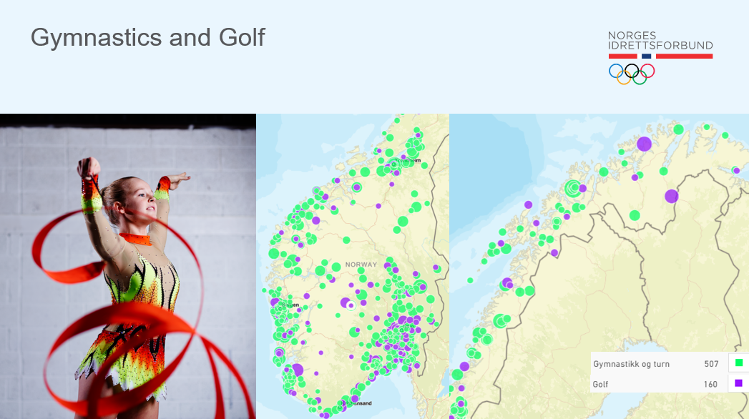

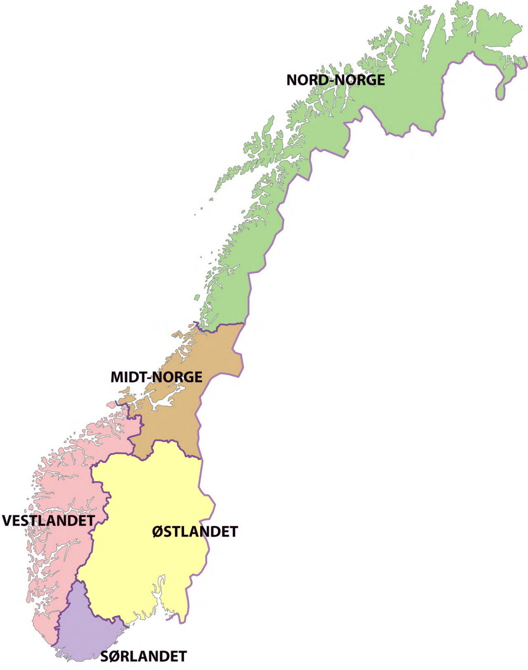
Appendix 11 The split of Norway into south and north.
Northern Norway
Mid-Norway
West Norway
East Norway
South Norway
North:
- Northern Norway
- Mid-Norway

South
- West Norway
- East Norway
- South Norway
Illustrates a map of Norway where det different parts of Norway are shown in different colours and the list shows which parts of Norway are defined as North and South

Appendix 12 Number of sports members in Athletics in Oslo
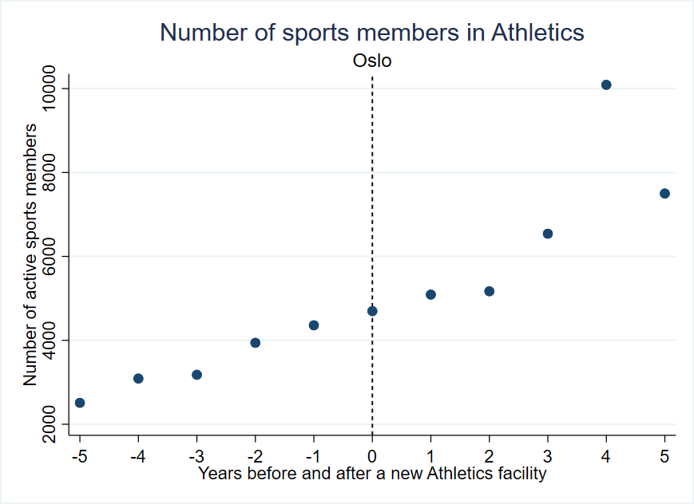
Figure The capital of Norway and built a new athletics facility within the period from 2003 to 2016. The graphs show how the actual activity in athletics had developed five years before and five years after the facility came. The x-axis represents years before and after a new facility were established in each municipality. The y-axis stands for the active sports members in the Norwegian athletics federation.

Appendix 13 Number of sports members in Athletics in Arendal, Asker, Kristiansand, Lunner and Tønsberg.
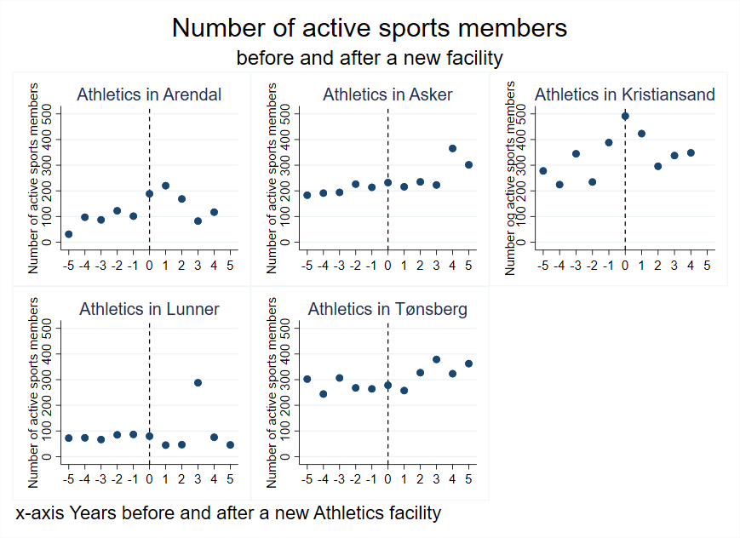
Figure The five graphs represents the municipalities Arendal, Asker, Kristiansand and Tønsberg which hare large municipalities in Norway and Lunner a medium sized municipality. These municipalities built new athletics facilities within the period from 2003 to 2016. The graphs show how the number of active sports members in athletics had developed five years before and five years after the facility came. The x-axis represents years before and after a new facility were established in each municipality. The y-axis stands for the number of active sports members in the Norwegian athletics federation.

Appendix 14 Number of sports members in Gymnastics in Lunner and Ringerike

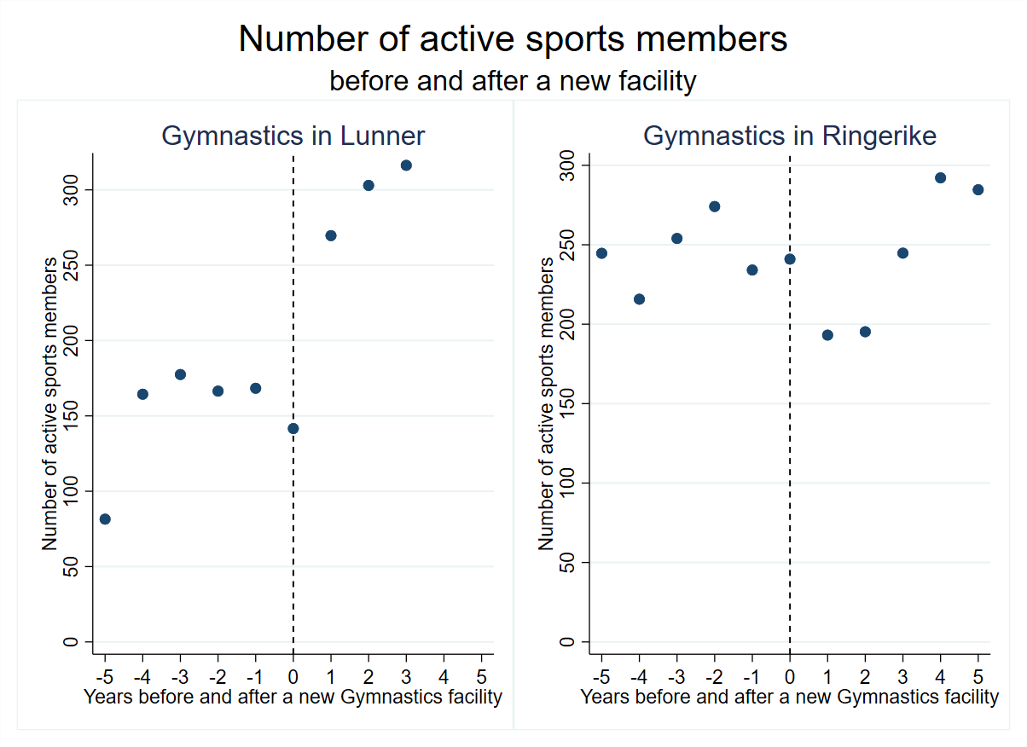
Figure 1 The two graphs represents the municipalities Lunner (medium municipality) and Ringerike (large municipality). These municipalities built new gymnastic facilities within the period from 2003 to 2016. The graphs show how the number of active members in gymnastic had developed five years before and five years after the facility came. The x-axis represents years before and after a new facility were established in each municipality. The y-axis stands for the number of active sports members in the Norwegian gymnastic federation.

Appendix 15 Number of sports members in Martial arts in Ringerike and Tønsberg

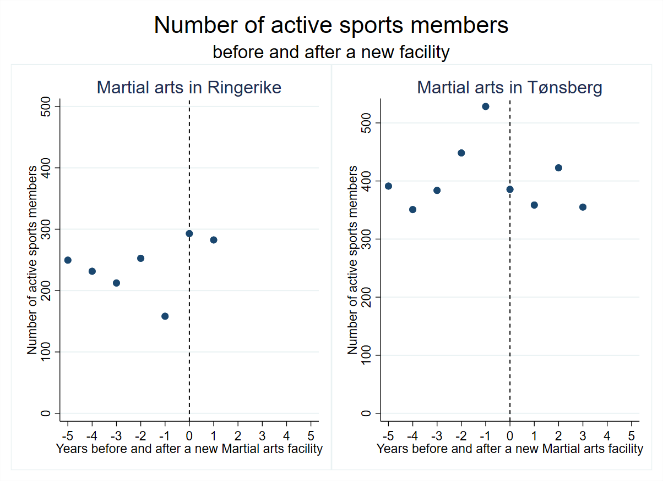
Figure 2 The two graphs represents the two medium municipalities Ringrike and Tønsberg. These municipalities built new martial arts facilities within the period from 2003 to 2016. The graphs show how the number of active members in martial arts had developed five years before and five years after the facility came. The x-axis represents years before and after a new facility were established in each municipality. The y-axis stands for the number of active sports members in the Norwegian martial arts federation.

Appendix 13 Activity in a large (Arendal) medium (Gjesdal) and small (Steigen) municipality all sports federations represented in that municipality.

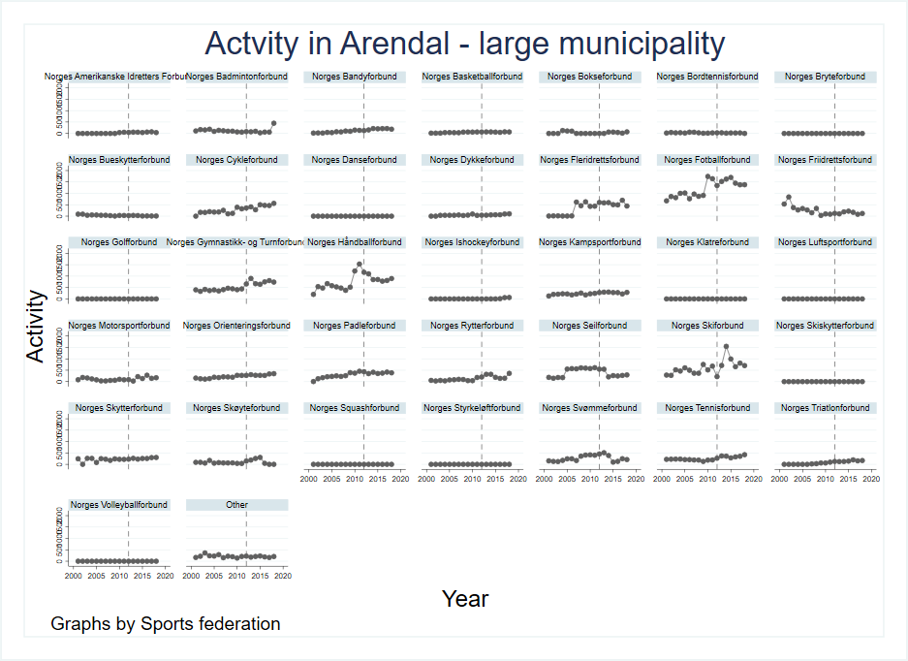

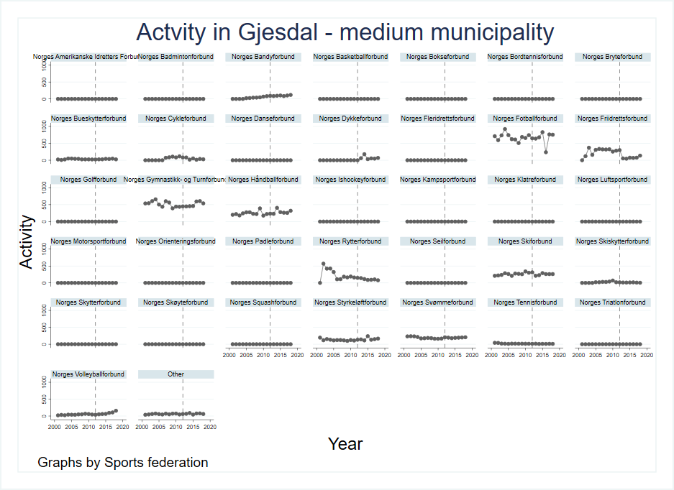

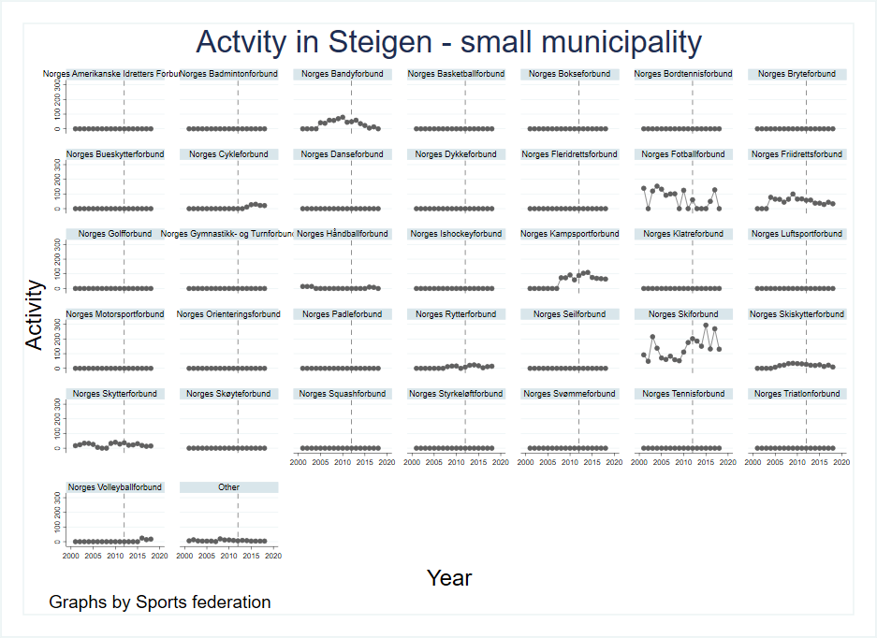

Appendix 14 Estimated coefficients for the subsets in the robustness check.

 | Norway | South | North
 | Active share per capita | Active share per capita | Active share per capita
# of sports specific Facilities per capita | 0.0019*** | 0.0026*** | 0.0012*
 | (0.0004) | (0.0006) | (0.0005)
N | 243682 | 167425 | 76257
R²  Within  Between  Overall | 0.0042  0.1142  0.0836 | 0.0041  0.1095  0.0860 | 0.0052  0.1281  0.0707
Time fixed effects | Yes | Yes | Yes
Standard errors in parentheses with clustered at mean level
* p < 0.05, ** p < 0.01, *** p < 0.001

 | Small | Medium | Large
 | Active share per capita | Active share per capita | Active share per capita
# of sports specific Facilities per capita | 0.0015** | 0.0023*** | 0.0022***
 | (0.0005) | (0.0007) | (0.0005)
N | 120805 | 87172 | 27787
R²  Within  Between  Overall | 0.0037  0.1204  0.0796 | 0.0057 0.1136  0.0924 | 0.0153 0.1398  0.1044
Time fixed effects | Yes | Yes | Yes
Standard errors in parentheses with clustered at mean level
* p < 0.05, ** p < 0.01, *** p < 0.001

